**E-COMMERCE using MERN STACK**

**By**

**HET BAKULESH MAMTORA**

**20BCE513**



**DEPARTMENT OF COMPUTER SCIENCE & ENGINEERING**

**Ahmedabad 382481**

**E-COMMERCE using MERN STACK**

**Major Project Report**

Submitted in partial fulfillment of the requirements

For the degree of

**Bachelor of Technology in Computer Science & Engineering**

By

**HET BAKULESH MAMTORA**

**20BCE513**

Guided By

**DR. RAVI NAHTA**

**[DEPARTMENT OF COMPUTER SCIENCE & ENGINEERING]**



**DEPARTMENT OF COMPUTER SCIENCE & ENGINEERING**

**Ahmedabad 382481**



**CERTIFICATE**

This is to certify that the B. Tech Major Project entitled “**E-COMMERCE using MERN Stack**” submitted by **Het Bakulesh Mamtora (20BCE513)**, towards the partial fulfillment of the requirements for the degree of Bachelor of Technology inComputer Science and Engineering of Nirma University is the record of work carried out by him/her under my supervision and guidance. In my opinion, the submitted work has reached the level required for being accepted for examination.

| Dr. Ravi Nahta ,  Assistant Professor,  Computer Science and Engineering Dept.,  Institute of Technology,  Nirma University,  Ahmedabad | Dr. Madhuri Bhavsar,  Professor and HOD,  Computer Science and Engineering Dept.,  Institute of Technology,  Nirma University,  Ahmedabad |
| --- | --- |

**ACKNOWLEDGEMENT**

The success and successful completion of my project took a great deal of direction and help from many people, I am incredibly fortunate to have received all this during the completion of my major project. I would like to take this opportunity to thank all for their guidance and support in everything that I have accomplished through this project.

I respect and thank Dr. Ravi Nahta sir for being the best mentor and most motivating person through out every stage of this project. Also, I am very much grateful to him for supporting me much and giving me this opportunity to do the major project work under his guidance, although having a busy schedule along with the academics, managing the corporate affairs, labs and lectures. Also, I would like to extend my respect and thanks to Mr. Daiwat Vyas sir and Dr. Zunnun Narmawala sir for providing me with extra guidance towards the project work on how the further execution and modifications should be done after what they reviewed during the review process of the project.

Along with this I am also grateful to some of my colleagues and to help me out with thinking and learning process of the project execution, also its ideation of how efficiently the project should give the outcome.

Last but not the least, I would like to thank my parents for constantly supporting me and boosting me though out my major project time period.

With this report I am further presenting all of my work and procedure that I have followed throughout my project completion.

**ABSTRACT**

Electronic commerce is the practice of conducting transactions using computer networks. A person can use the Internet’s purchasing and selling capabilities while seated in front of a computer. With this motive came the idea of making an E-Commerce web application using the latest technology in IT industrial sector termed as MERN Stack.

Development of this project started along with first learning all the technologies which take part in MERN Stack mainly MongoDB for NoSQL databases, Express JS for back-end configuration, React JS for front-end configuration and Node JS for server configuration. Also along with these technologies I did learnt REST API and Redux configuration for API calling and state management.

Learning phase of all these technologies gave me a brief idea of how I would be working on my E-Commerce platform making it a completely responsive and user friendly web application following up the industrial practice of first designing the backend of the project and validating all the APIs then moving onto the frontend part where data is stated through the APIs which are routed in the backend.

All of this helped me in making a working E-Commerce platform using the MERN Stack technology.

**LIST OF TABLES AND FIGURES**

| **TABLES** | |
| --- | --- |
| *Table 2.1* | *Hardware Requirements* |
| *Table 2.2* | *Software Requirements* |
| *Table 2.3* | *DFD Symbols* |
| **FIGURES** | |
| *Fig1.1* | *Structure of MERN Stack* |
| *Fig2.1* | *DFD 0Level / Context Diagram* |
| *Fig2.2* | *Backend Data Flow* |
| *Fig2.3* | *DFD 1st Level – ADMIN* |
| *Fig2.4* | *DFD 1st Level – USER* |
| *Fig2.5* | *DFD 2nd Level – ADMIN 3.0* |
| *Fig2.6* | *DFD 2nd Level – ADMIN 4.0* |
| *Fig2.7* | *DFD 2nd Level – ADMIN 5.0* |
| *Fig2.8* | *DFD 2nd Level – USER 5.0* |
| *Fig2.9* | *DFD 2nd Level – USER 6.0* |
| *Fig3.1* | *System Flow* |
| *Fig3.2* | *ER Diagram* |

# **CONTENTS**

| **Certificate** |  | **III** |
| --- | --- | --- |
| **Acknowledgement** |  | **IV** |
| **Abstract** |  | **V** |
| **List of Figures and Tables** |  | **VI** |
|  |  | |

**CHAPTER – 1: Introduction 1**

**1.1** **TECHNOLOGY STACK 1**

1.1.1 Introduction to MERN Stack. 1

1.1.2 How MERN Stack Works ? 1

1.1.3 Technologies Used 2

**1.2 THE SYSTEM 3**

1.2.1 Definition of System 3

1.2.2 Purpose and Objectives 3

1.2.3 Proposed System 4

**1.3** **PROJECT PROFILE 6**

2.1.1 Project Title 6

2.1.1 Scope of Project 6

2.1.1 Project Team 7

**CHAPTER – 2: System Analysis 8**

**2.1** **FEASIBILITY STUDY 8**

2.1.1 Operational Feasibility 8

2.1.2 Technical Feasibility 8

2.1.3 Economical Feasibility 9

2.1.4 Project Planning 9

**2.2** **REQUIREMENT ANALYSIS 11**

2.2.1 Software Requirements Specification 11

2.2.2 Operating Environment 12

2.2.3 Functional Requirements 12

2.2.4 Non-Functional Requirements 13

**2.3** **CONTEXT DIAGRAM 14**

2.3.1 DFD 0 Level Diagram 14

2.3.2 Backend Flow 15

**2.4** **DATA FLOW DIAGRAMS 16**

2.4.1 First Level DFD Diagram 16

2.4.2 Second Level DFD Diagram 17

**CHAPTER – 3: System Design 20**

**3.1** **System Flow 20**

**3.2** **Entity Relationship Diagram 22**

**3.3** **Data Dictionary 23**

**CHAPTER – 4: Execution and Functionality 28**

**4.1** **Execution 28**

**4.2** **Admin Dashboard Functionality 35**

**CHAPTER – 5: User Manual 39**

**5.1** **Menu Screens and Forms along With Description 39**

**CHAPTER – 6: Testing 46**

**6.1** **Importance of Testing 46**

**6.2** **API Routes Testing 46**

**CHAPTER – 7 : Future Work & Conclusion 51**

**7.1** **Future Work 51**

**7.2** **Conclusion 51**

**APPENDIX 52**

**BIBLIOGRAPHY 53**

**TURNITIN REPORT 54**

# **CHAPTER – 1: Introduction**

## **TECHNOLOGY STACK**

### **Introduction to MERN Stack.**

The phrase "MERN Stack" relates to a Full Stack technology in order or the totality of an application for a computer system. Full Stack is a web development framework that combines the front-end and back-end. The back-end, on the other hand, consists of all the servers, databases, and other underlying architecture that power the program; frequently, the end-user actually never interacts with this realm directly. The front end of a website is all of what a client, or site viewer, is able to see and interact with.

MongoDB serves as a document-based database, Express JS serves as a web-based framework, React JS serves as a client-side java script framework mostly for the front-end portion of applications, and Node JS serves as a leading java script web server. These four technologies make up the MERN Stack.

### **How MERN Stack Works ?**

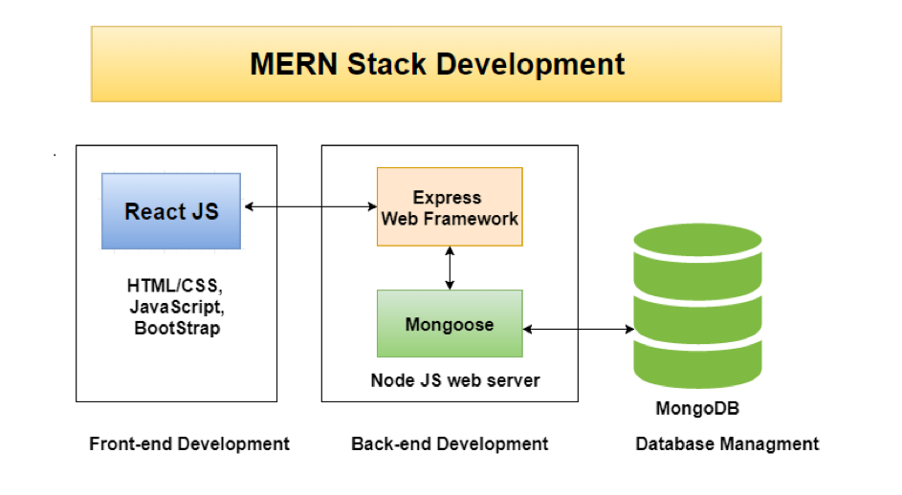

***Fig 1.1 Structure of MERN Stack***

### **Technologies Used**

1. **MongoDB –** MongoDB is a document database that combines the necessary indexing and querying with the scalability and flexibility you require. Since the documents that MongoDB uses to store its data are adaptable and JSON-like, their fields can differ from one document to the next and their data structures can evolve over time. Data manipulation is made simple by the document model, which corresponds to the objects in your application code.
2. **Express JS –** Express is a Node.js framework for online applications that is adaptable and provides a robust set of features for mobile as well as web applications. Considering you have access to numerous HTTP service methods and middleware, creating a robust API is quick and easy. Express provides a thin layer of fundamental web application operations while keeping the well-known and adored Node.js characteristics.
3. **React JS –** The JavaScript framework and library React.js was developed by Facebook. It is used to quickly and effectively create interactive user interfaces and web applications with a lot less code than you would need to write if you were using plain-vanilla JavaScript. React manages the view layer by providing the most effective and efficient rendering implementation as the V in the model-view-controller (MVC) paradigm.
4. **Node JS –** Node JS is a JavaScript runtime environment that is open source and cross-platform. Developers don't have to learn another language because Node is widely used for server-side development, allowing them to incorporate JavaScript for both client- and server-side code. Node.js is made to enable the development of scalable network applications using the asynchronous mode event-driven JavaScript runtime.
5. **Redux Toolkit** – A Redux toolkit is a set of tools that enables you to create listener entries that include an impact call-back with added logic and a way to control the timing of when that call-back is supposed to be executed depending on delivered actions or state changes.

## **1.2 THE SYSTEM**

### **Definition of System**

Consumers are increasingly favoring online purchasing, but the convenience and expansion of these platforms are faced by a number of issues. Poor user experience is one of the biggest obstacles, because so many platforms have cluttered sites and unclear options that make it difficult for users to locate what they're searching for. The fact that there are few payment options is also a problem because not all customers may find the choices satisfactory. Both buyers and sellers are very concerned about security because security lapses can result in fraudulent transactions and the theft of personal data. Moreover, customers may become impatient with lengthy website loading times.

Customers desire for online shopping has grown significantly, but e-commerce sites are struggling with a number of issues that limit their growth and convenience. The bad user experience that these platforms endure is their biggest obstacle. The majority of platforms have confusing menus and crowded websites, making it challenging for clients to find the things they want. Limited payment alternatives are also a problem because not all customers will find the offered options suitable. Security breaches that could result in scams and compromised personal information worry both consumers and sellers. Additionally, customers may become impatient with longer page loading times.

### **Purpose and Objectives**

My innovative e-commerce platform is designed to change the online shopping experience for both buyers and sellers. I have identified the common challenges faced by existing e-commerce platforms and have predefined set of objectives to overcome them. The user-friendly interface, extensive range of payment options, and strict security measures ensure that our platform provides a seamless and secure shopping experience. The interactive menus and clear product cards make browsing of products an easy outcome, and our front-end react technology eliminates the need for page reloads, allowing for faster and more efficient shopping. Trust us to provide a reliable and enjoyable online shopping experience like no other.

### **Proposed System**

I am excited to present our MERN-based, carefully constructed e-commerce platform, which combines the strengths of MongoDB, Express, React, and Node.js. I have used React to create an intuitive, responsive, and seamless user experience that responds in real-time to user actions. I have included Node.js to control server-side processing and database interactions in order to give results as quickly as possible. Express has been used to construct our versatile and reliable API, making extension and maintenance an ease of job. Scalability, dependability, and security for customer and product data are ensured with MongoDB as the database. Redux also controls application state, ensuring dependability and consistency.

My goal is to provide an e-commerce platform that's fast, responsive, and reliable, catering to both buyers and sellers with a vast array of features and secure transactions. Our MERN stack and Redux leverage a scalable data storage solution, a different number of payment options, and a seamless user experience that eliminates the need for page loading. These technologies allow us to deliver a modern e-commerce platform that's efficient, scalable, and caters to a large customer base.

My e-commerce platform is equipped with Stripe integration, which guarantees our customers a hassle-free payment experience. With stripe accessed in it, it offers a different categories of payment options, including credit & debit card payments, making it easier for our customers to choose the method that suits them best. Moreover, Stripe's security features are top-notch, ensuring that our customers' sensitive data is always protected. It is PCI-compliant, which means that it sticks to the strictest standards when it comes to handling and storing payment information. With Stripe, I can assure my customers that their payment information is in safe hands, giving them the confidence to shop within my portal worry-free.

To enhance the speed and effectiveness of my platform, I have successfully implemented a Content Delivery Network (CDN) exclusively for images. A CDN is a network of servers distributed geographically that directs content and delivers it to users based on their location. By leveraging the power of CDN, I can reduce the strain on our servers and provide a faster, more dependable user experience, especially for those having slower internet connectivity. This ensures that my platform loads images rapidly, delivering a smooth and satisfying shopping experience to my customers.

Furthermore, I have also integrated Cloudinary as my portal's image management platform, which is a robust cloud-based service that allows me to store, manage, and edit images for my e-commerce platform. This feature allows me to mediate and optimize the images for faster loading times and ensure that they are formatted correctly for various device types and screen sizes. This translates into an effortless user experience, with superior product images that are optimized for speed and consistency. Rest assured, with my latest tech stack used, I guarantee to provide a better user experience for my customers.

## **PROJECT PROFILE**

### **Project Title**

A fully working online shopping platform utilizing the components of the MERN (MongoDB, Express.js, React, Node.js) technological stack is what the project title "E-Commerce using MERN Stack" speaks to. The goal of this project is to develop an online store with an easy-to-use interface for exploring products, adding items to carts, making purchases, and following up on orders.

At the end, my project of "E-Commerce using MERN Stack" is vastly inclined to develop a web application that is fulfilling the needs of modern e-commerce shopping experience and varied features in it including advance level security by bifurcating the logged in user roles as admin and an end-user, following up with delivering an easy product surfing experience for the customers. This web application is having MERN Stack's powerful tools and varied features to create a user friendly, scalable, responsive and reliable e-commerce shopping platform.

### **Scope of Project**

The main scope of this project is to build an online shopping platform that is both easy to navigate without page re-loading and provides customers with a smooth shopping experience with filtered options. Additionally, admins will have access to a user-friendly dashboard that enables them to manage their products, orders, users and details of sales which are undergoing on the portal. The project being made with NodeJs and Express backend enables a restful API generation, and efficient server-side processing. The frontend will be user-friendly, easy menus, clear product cards, and real-time updates as all of the front-end is based on the ReactJS. For security management I have used technique of secure authentication and hash encryption so users don't have to worry about their information.

One of the key challenges in developing an e-commerce platform is to make sure that the website handles high traffic load while accessing the contents of the page and avoid crashing the server .To achieve this, the platform will need to be designed with scalability in mind, including the ability to handle large numbers of users. To achieve this I am using the load balancing features provided by the Mongo DB cluster. Additionally, the platform will need to be optimized for performance, with a focus on reduce the load times hence we use react as a Front-End and use CDN for loading the images. By addressing these challenges and ensuring that the platform is both scalable and performance oriented, I can provide customers with a seamless and responsive shopping experience while supporting the growth of my e-commerce web application.

### **Project Team**

As per the guideline of the major project provided by the university we were instructed to do this project on standalone basis where I Initially started to learn the basics of all technologies and frameworks used in my project. Than I started developing the backend and tested all the routes of Express through Postman. Once the backend was ready I moved on to developing the front-end part using react framework. Throughout this process, I was able to create a functional and reliable e-commerce platform that met the needs of modern online shopping and user friendly dashboard for admins to maintain the whole web application portal.

# **CHAPTER – 2: System Analysis**

## **FEASIBILITY STUDY**

### **Operational Feasibility**

* Operational feasibility determines if the project can be completed with available resources.
* Factors like available technology, human resources, etc are considered for determining feasibility.
* Operational feasibility ensures the project is scalable and functional within resource constraints.
* In my e-commerce project, operational feasibility is crucial for creating a user-friendly and secure platform.
* The platform must meet the needs of customers while being scalable and reliable.

Another aspect of operational feasibility is the ease of use of the platform. The e-commerce platform should be user-friendly, allowing customers to quickly browse products, add them to their cart, and make purchases without any hassles. Additionally the web app is responsive as a result the website can be access and viewed across multiple devices such as tablet and mobile devices.

### **Technical Feasibility**

Technical viability considers accessibility of hardware and software, maturity and compatibility of technology, and availability of technical manpower.

* MERN Stack and VS Code were chosen for system creation.
* MERN Stack was used for both backend and frontend development.
* VS Code was used as the IDE for project development.
* Backend server and APIs were created first, followed by frontend design.

Further the feasibility study can be more elaborated as technologies of MERN for example MongoDB offers a flexible and scalable database, Express.js makes the process of building RESTful APIs and also handling all the routes of the application very easy, ReactJS offers dynamic and responsive user interfaces as a result the client won't be able to experience any lag or loading while navigating through different parts of the page. These powerful tools and features of MERN stack has helped me to improve the performance of the project

### **Economical Feasibility**

It is the measure of financial standability and effectiveness of the project. Not a big issue, it is only about calculating the importance of developing the project and also solving the problems in the current system is worth the time or not. Currently, at the development level as a freelance project so no current solution and requirements have been found at this stage. However when a specific stage of this project is reached like when the project is ready to be deployed for fully functional features and a buyer of this project comes into picture then the cost and economical feasibility can be analyzed according to the requirements of the client.

### **Project Planning**

Project planning is an important component of software development projects, more specifically for e-commerce platforms built using the MERN stack. This phase involves

* Analyzing the project definition.
* Defining different phases of project.
* Identifying technical and system requirements.
* Making the general flow of the entire project system.
* Creating a detailed well managed project plan with all the time stamps of different phases and setting the goals.

The most important features and functions for an e-commerce platform, such as product listings, a shopping cart, and secure payment processing, must be identified. A development schedule for the platform should be included in the project plan, with checkpoints specified for the fulfilment of key functionality.

Project planning considers several significant factors, which includes

* Defining project goals.
* Identifying requirements.
* Allocating resources.
* Creating a well-defined timeline.
* Establishing a project budget.
* Address potential risks and provide strategies to solve and avoid them.

Planning should be done in early stages so that in case of system failure procedures which are defined are followed thereby avoids the risk of delays and additional costs.

In conclusion, effective project planning is vital to the success of any project, especially for complex projects like e-commerce platforms built using the MERN stack. By defining goals, requirements, and identifying potential challenges, I can ensure a smooth and successful development process.

## **REQUIREMENT ANALYSIS**

### **Software Requirements Specification**

Currently the e-commerce platforms do have rapid growth over the last ten years and is still expanding at an exponential rate. Because it is so convenient and accessible, many people now choose to shop online. Businesses are now trying to create ecommerce platforms that give customers a seamless shopping experience as a result. Future company initiatives and ideas are moving more and more online.

The goal of this project is to leverage the MERN (MongoDB, Express, React, Node.js) stack to develop a user-friendly and responsive e-commerce platform. Customers can buy the merchandise through this site. The system will also have an administrative panel for handling products, orders, and user data. The major purpose of this project is to function as a middleware for both the customer as well as the vendor for seamless shopping experience.

* Hardware Requirements

Hardware requirements refer to the specific physical components that are needed to run the software. In our case following are the requirements

| **Processor** | Intel Core i3 or above |
| --- | --- |
| **RAM** | 4 GB RAM or Above |
| **Storage** | 128 GB Recommended or above |
| **Display** | 1280 x 720 for desktop browsing and dynamically responsive over tablets and mobile platform |
| **Network** | Stable and reliable internet connection |

***Table 2.1 Hardware Requirements***

* Software Requirements

| **Operating System** | Supported over windows/ MacOS / Linux |
| --- | --- |
| **Database** | MongoDB |
| **Programming Languages** | HTML, CSS, JavaScript |
| **Frameworks** | React, Node, Express, Redux Toolkit |
| **3rd Party API** | Stripe, Cloudinary |
| **DevTools** | VSCode, Postman, Mongo Shell, SMTP mail Protocol |

***Table 2.2 Software Requirements***

### **2.2.2 Operating Environment**

The success of an ecommerce app depends heavily on its operational environment, which encompasses several critical aspects. These include infrastructure, network architecture, and security measures.

To handle a large number of users, the infrastructure must be scalable, reliable, and highly available. Similarly, the network architecture must be designed to handle high volumes of traffic, ensuring low latency for a seamless user experience.

Security is also a top priority in the operational environment of an ecommerce app, with protection against various threats like DDoS attacks, SQL injection, and cross-site scripting being paramount. To safeguard user data and prevent unauthorized access, encryption, firewalls, and intrusion detection and prevention systems must be in place

### **Functional Requirements**

Functional requirements refer to the specific tasks and features that the software must perform in order to meet the needs of the user. functional requirements for an e-commerce app might include:

* Account creation and sign in/out functionality.
* Advanced search options allowing users to search for products by category, brand, or keyword.
* Shopping cart integration enabling users to add products and checkout with ease.
* Order tracking and history to keep users informed throughout the shipping process.
* Product review and rating system allowing users to leave feedback and share their experience with others.

### **Non-Functional Requirements**

Non-functional requirements are related to the effectiveness of software in carrying out its functions. They reference to aspects such as performance, security, reliability, and other elements that affect the user's experience.

Non-functional requirements for an e-commerce app might include:

* **Response Time:** The time it takes for the app to respond to user input.
* **Availability:** The percentage of time that the app is up and running.
* **Security:** The measures in place to protect user data and prevent unauthorized access.
* **Usability:** The ease of use and user-friendliness of the app.
* **Scalability:** The ability of the app to handle increasing levels of traffic and users.

## **CONTEXT DIAGRAM**

The system under study is depicted in the context diagram as one high-level procedure, followed by a relationship between the system and various external entities. A context diagram may also be referred to as a level-0 data flow diagram or context-level data flow diagram. A customized variant of a data-flow diagram is a context diagram.

DFD illustrates four basic components and is process-centric.

|  | **Data Flow –**Data flow are pipelines through the packets of information flow. |
| --- | --- |
|  | **Process –** A process or a task performed by the system. |
|  | **Entity –** Entities are object of the system. A source or destination data of a system. |
|  | **Data Store –** A place where data to be stored. |

***Table 2.3 DFD Symbols***

### **2.3.1 DFD 0 Level Diagram**

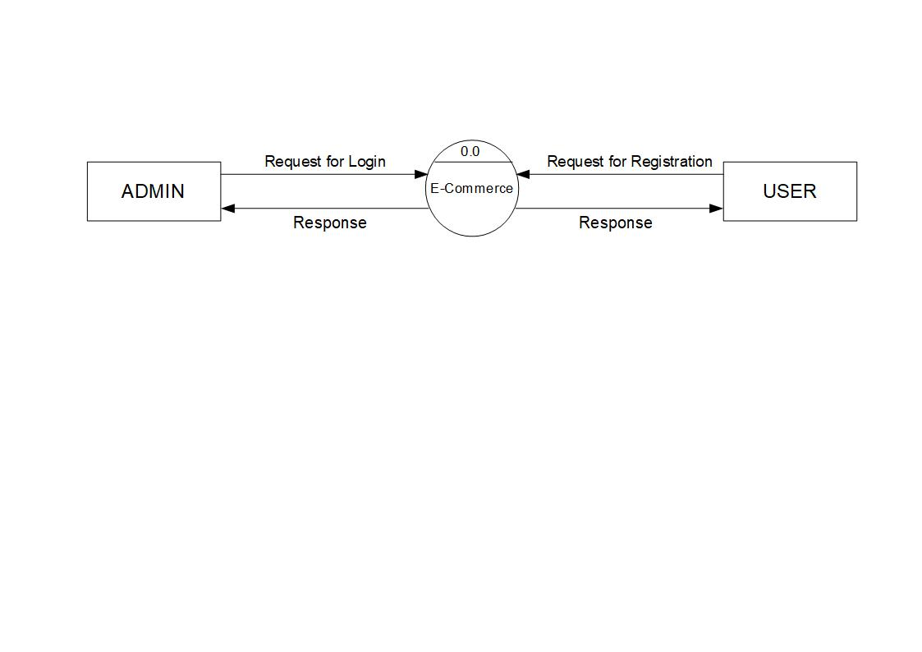

***Fig 2.1 DFD 0 Level / Context Diagram***

### **Backend Flow**

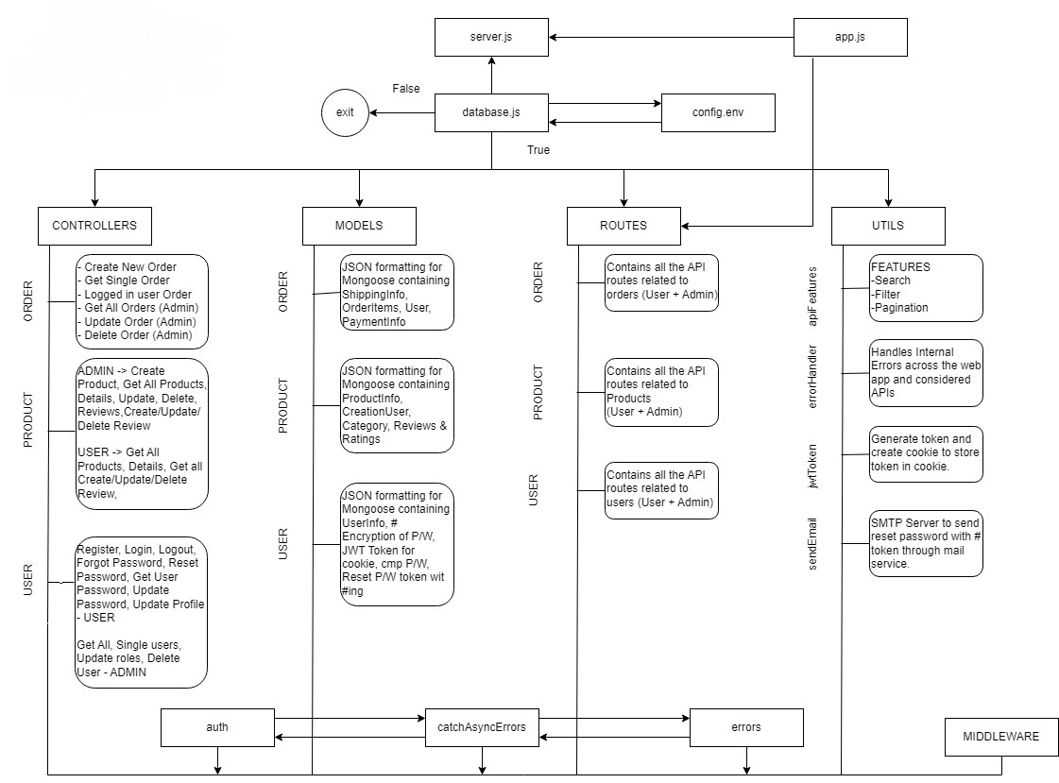

***Fig 2.2 Backend Data Flow***

## **DATA FLOW DIAGRAMS**

### **First Level DFD Diagram**

* ADMIN

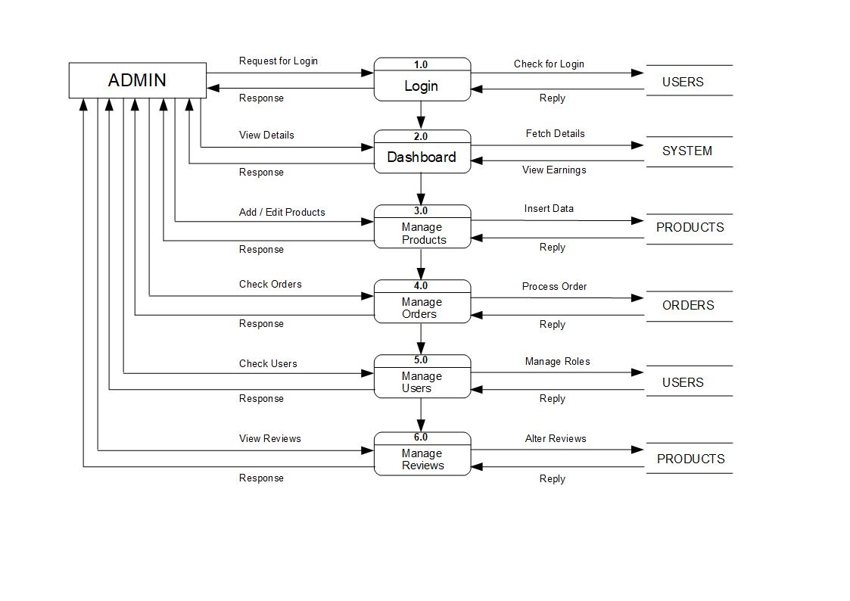

***Fig 2.3 DFD 1st level – ADMIN***

* USER

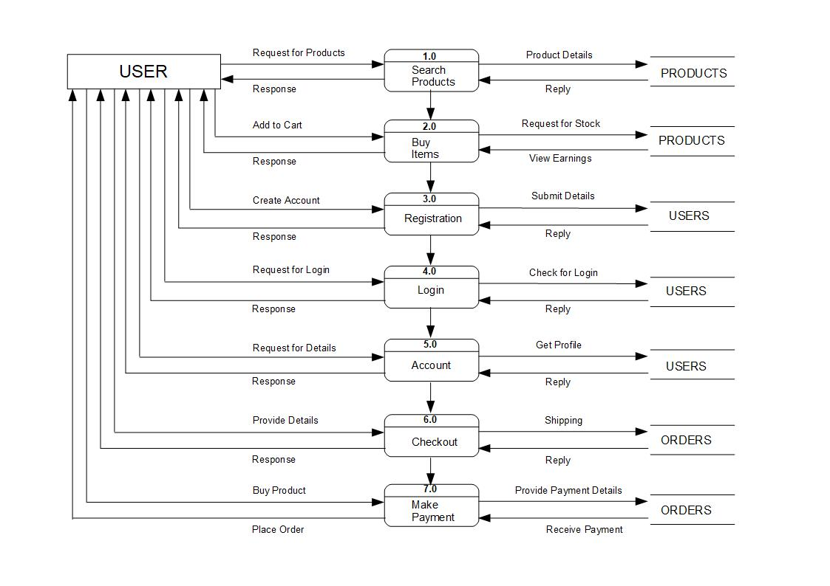

***Fig 2.4 DFD 1st Level – USER***

### **Second Level DFD Diagram**

* ADMIN

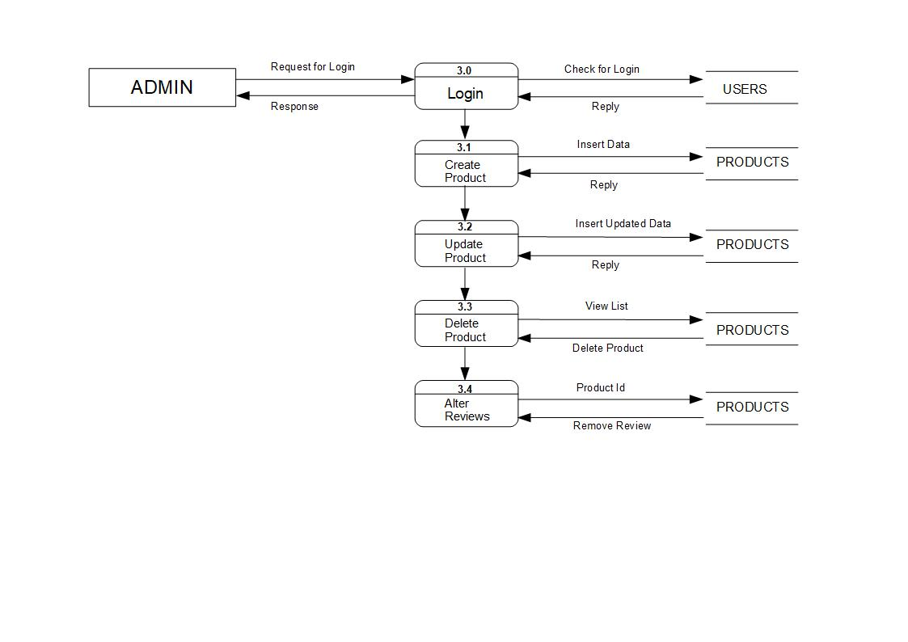

***Fig 2.5 DFD 2nd Level – ADMIN 3.0***

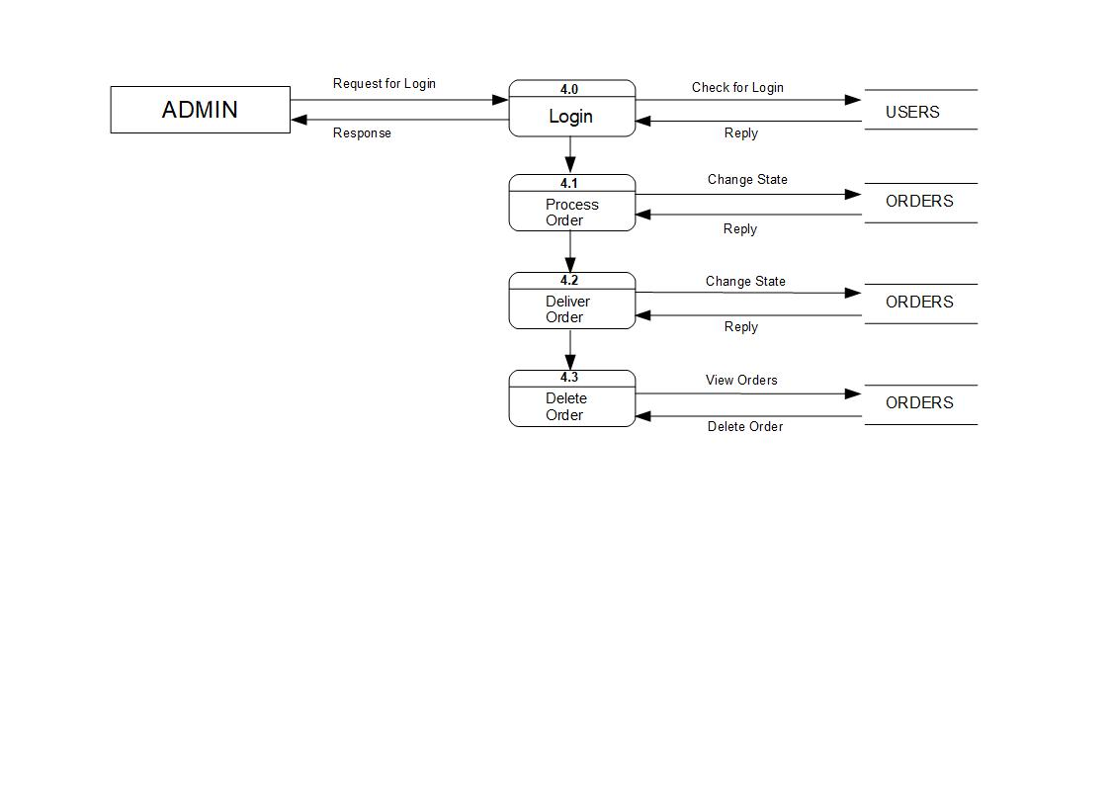

***Fig 2.6 DFD 2nd Level – ADMIN 4.0***

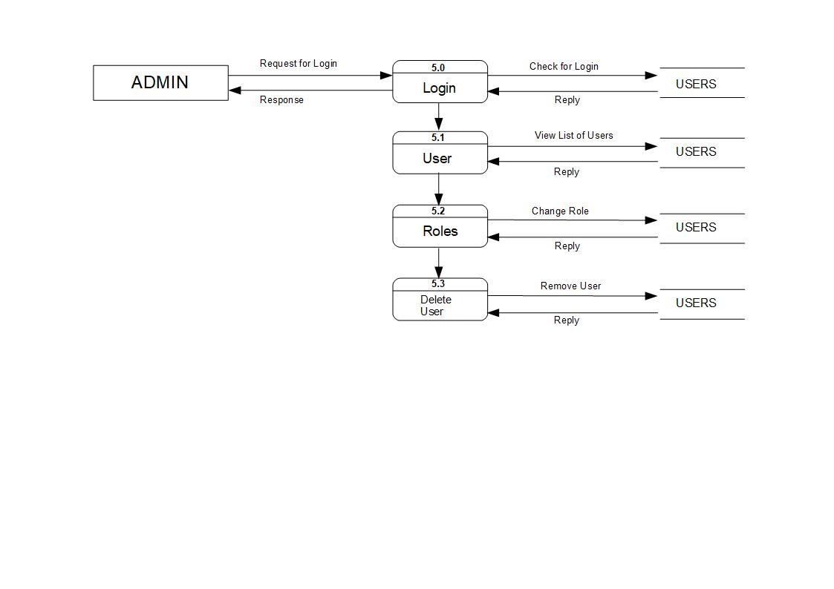

***Fig 2.7 DFD 2nd Level – ADMIN 5.0***

* USER

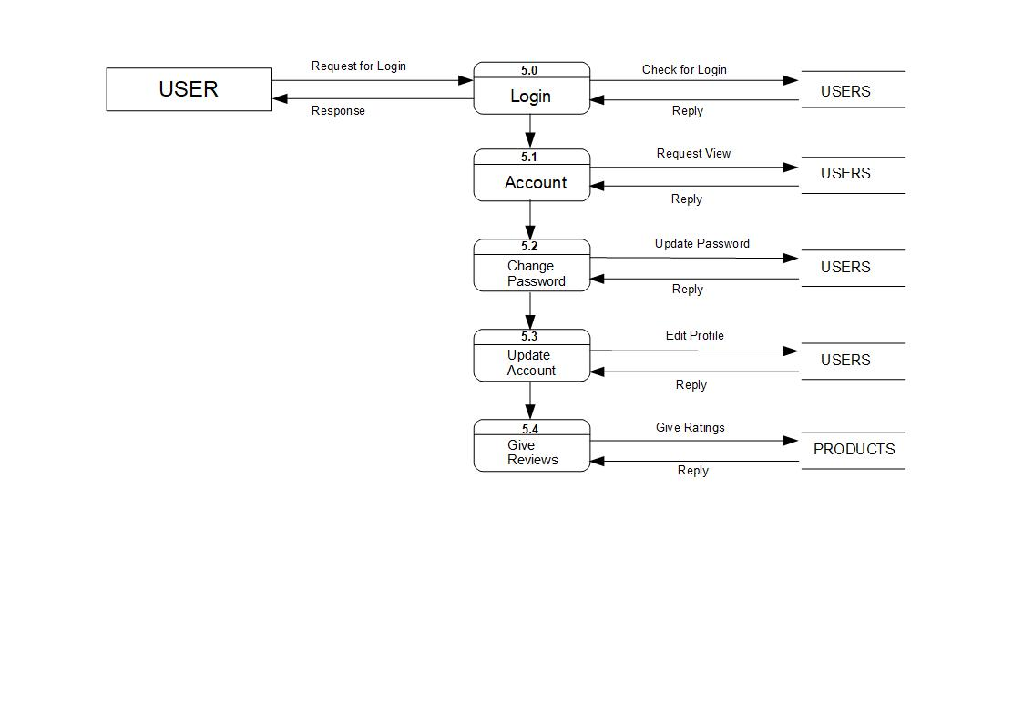

***Fig 2.8 DFD 2nd Level – USER 5.0***

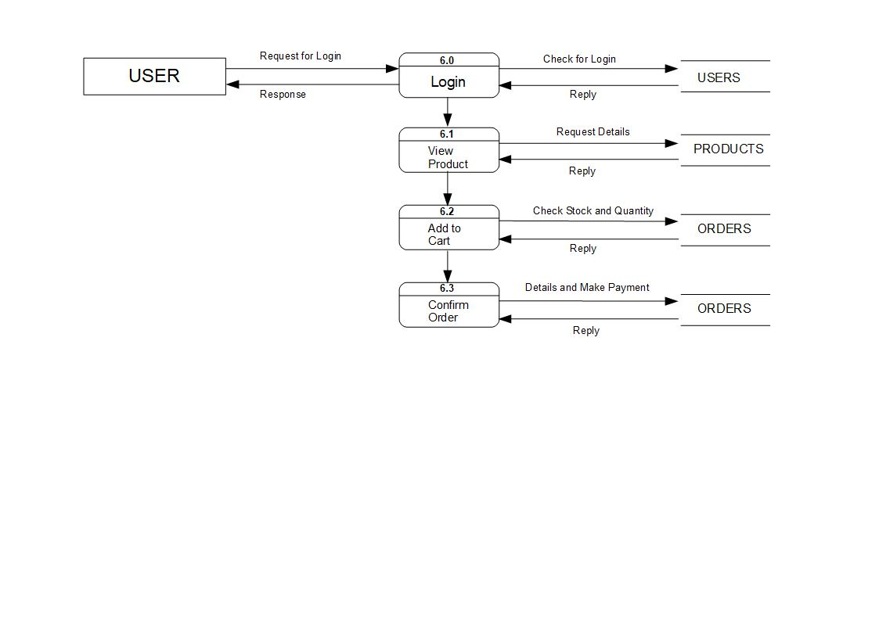

***Fig 2.9 DFD 2nd Level – USER 6.0***

# **CHAPTER – 3: System Design**

## **System Flow**

* E-Commerce 🡪 Admin
* Admin can get List of products, orders, reviews of products, users.
* Admin can get total orders, earnings, products, users.
* Admin 🡪 E-Commerce
* Admin can manage whole platform
* Can have dashboard access
* Can process and deliver the order
* Manage the product
* User role change
* E-Commerce 🡪 User
* Provide product details
* Access cart
* Token to reset password
* User 🡪 E-Commerce
* Place Order
* Make Payment
* Provide Shipping Details
* Give Review
* E-Commerce 🡪 Guest
* Display products
* Filter Optimization
* Add to cart
* Guest 🡪 E-Commerce
* Registration
* Checkout details
* Update details

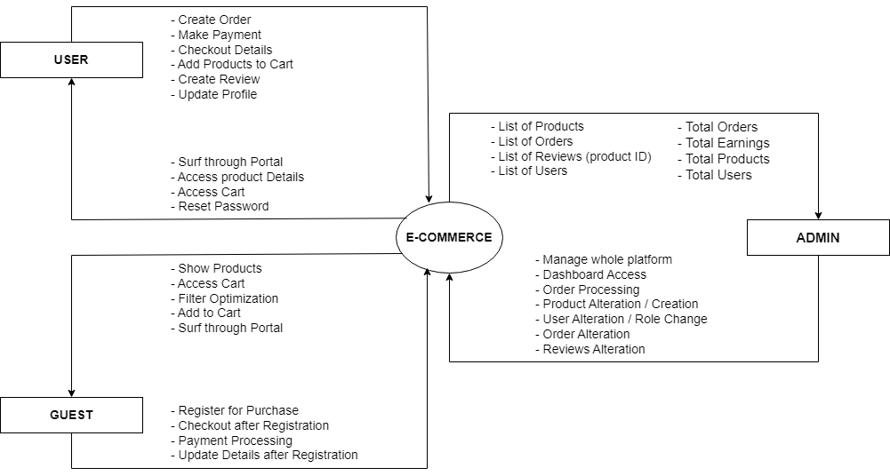

***Fig 3.1 System Flow***

## **Entity Relationship Diagram**

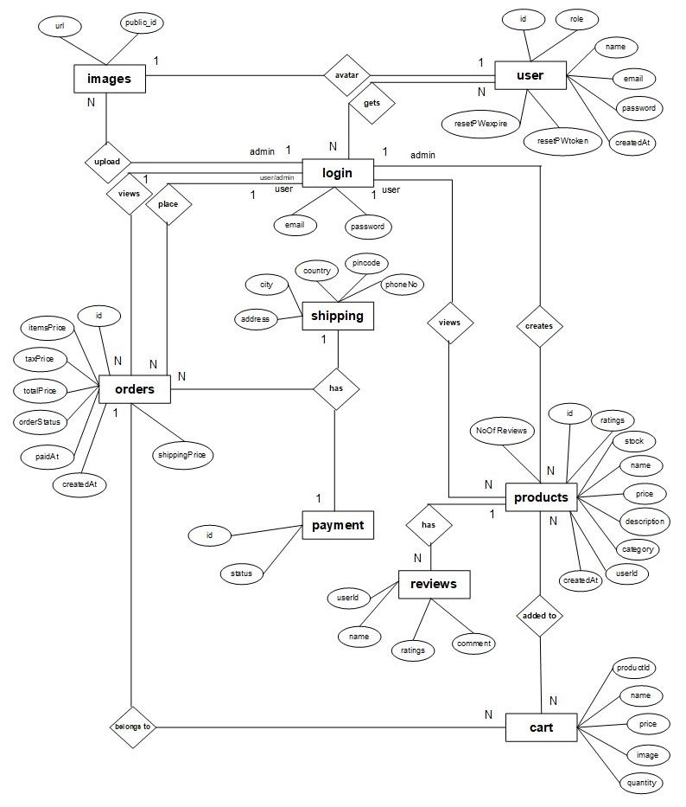

***Fig 3.2 ER Diagram***

## **Data Dictionary**

* Products

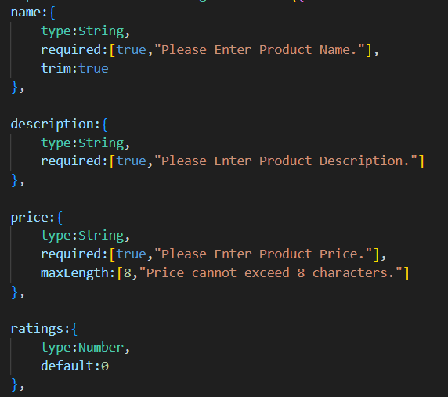

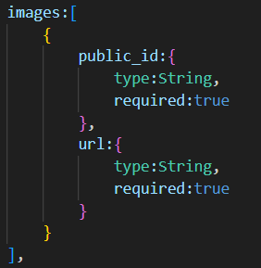

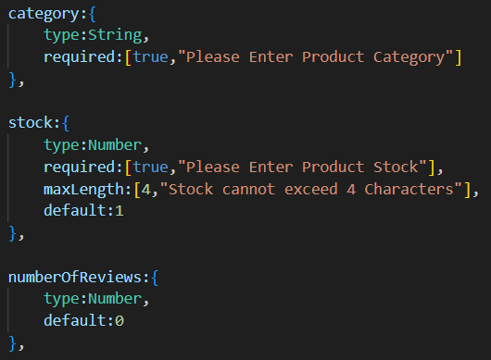

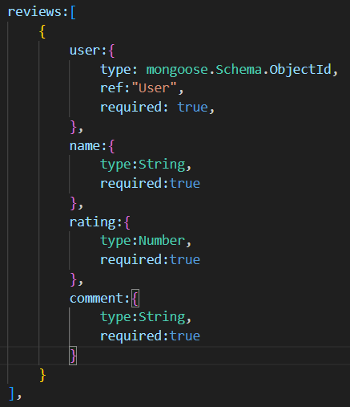

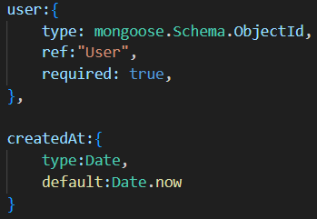

* Orders

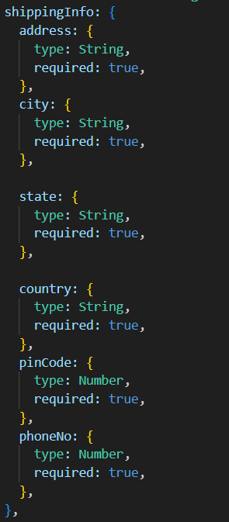

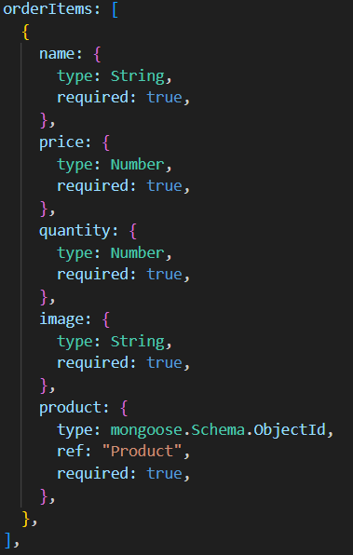

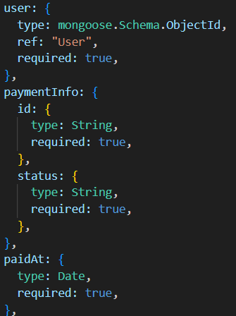

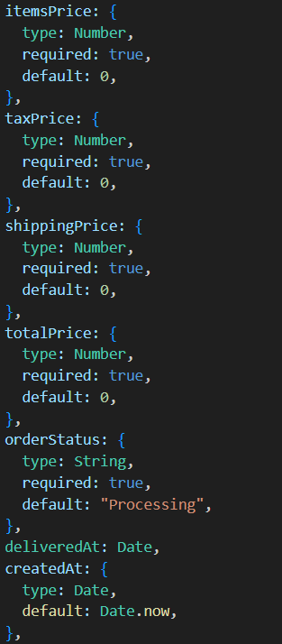

* Users

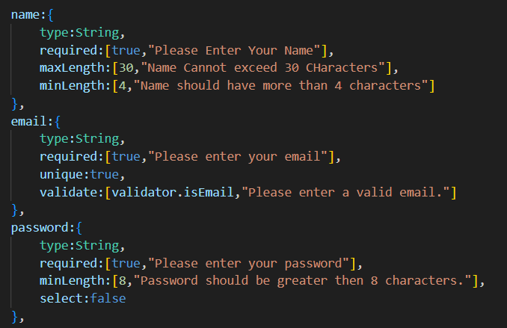

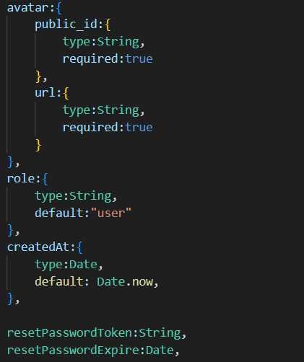

# **CHAPTER – 4: Execution and Functionality**

## **Execution**

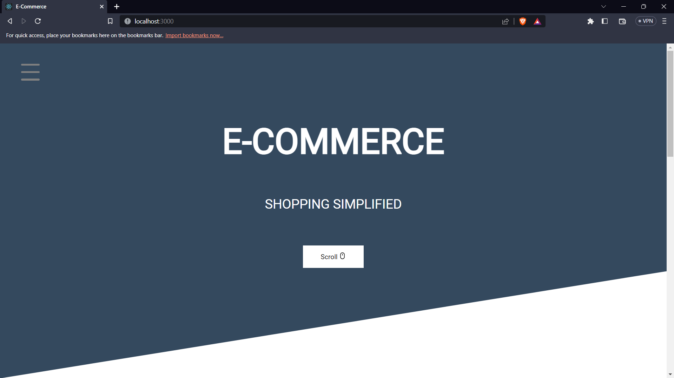

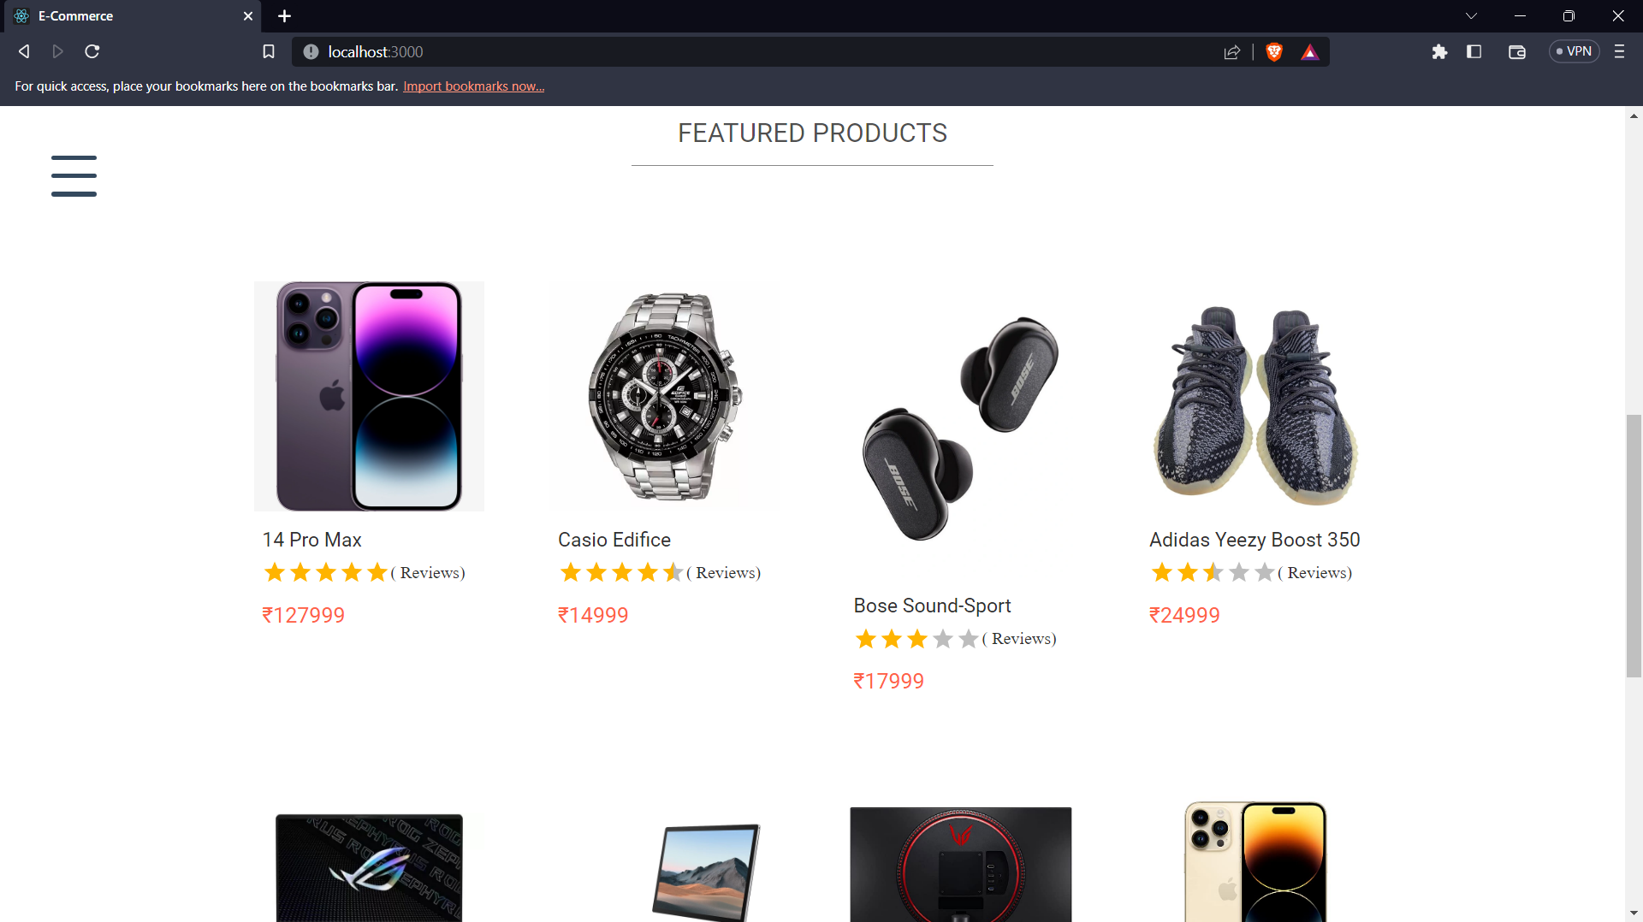

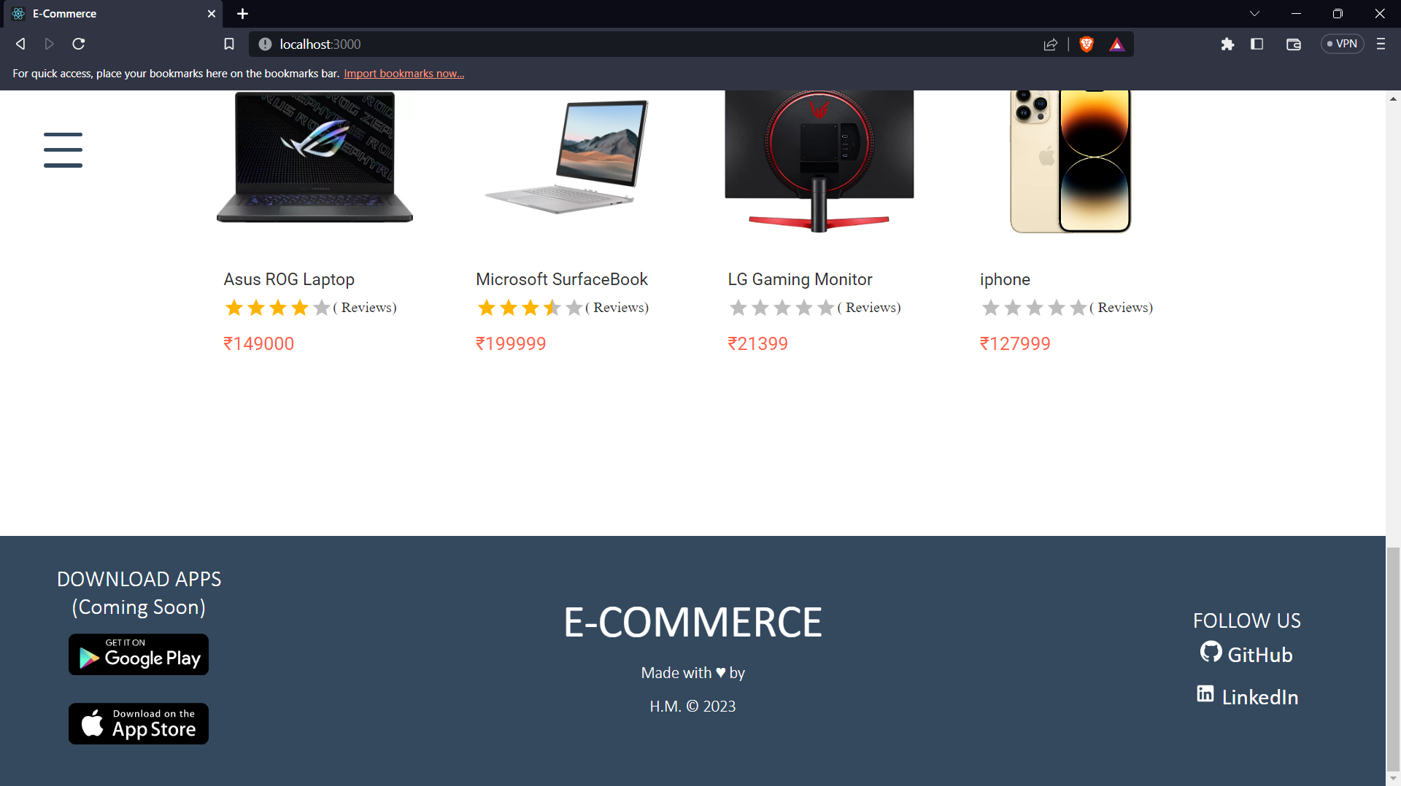

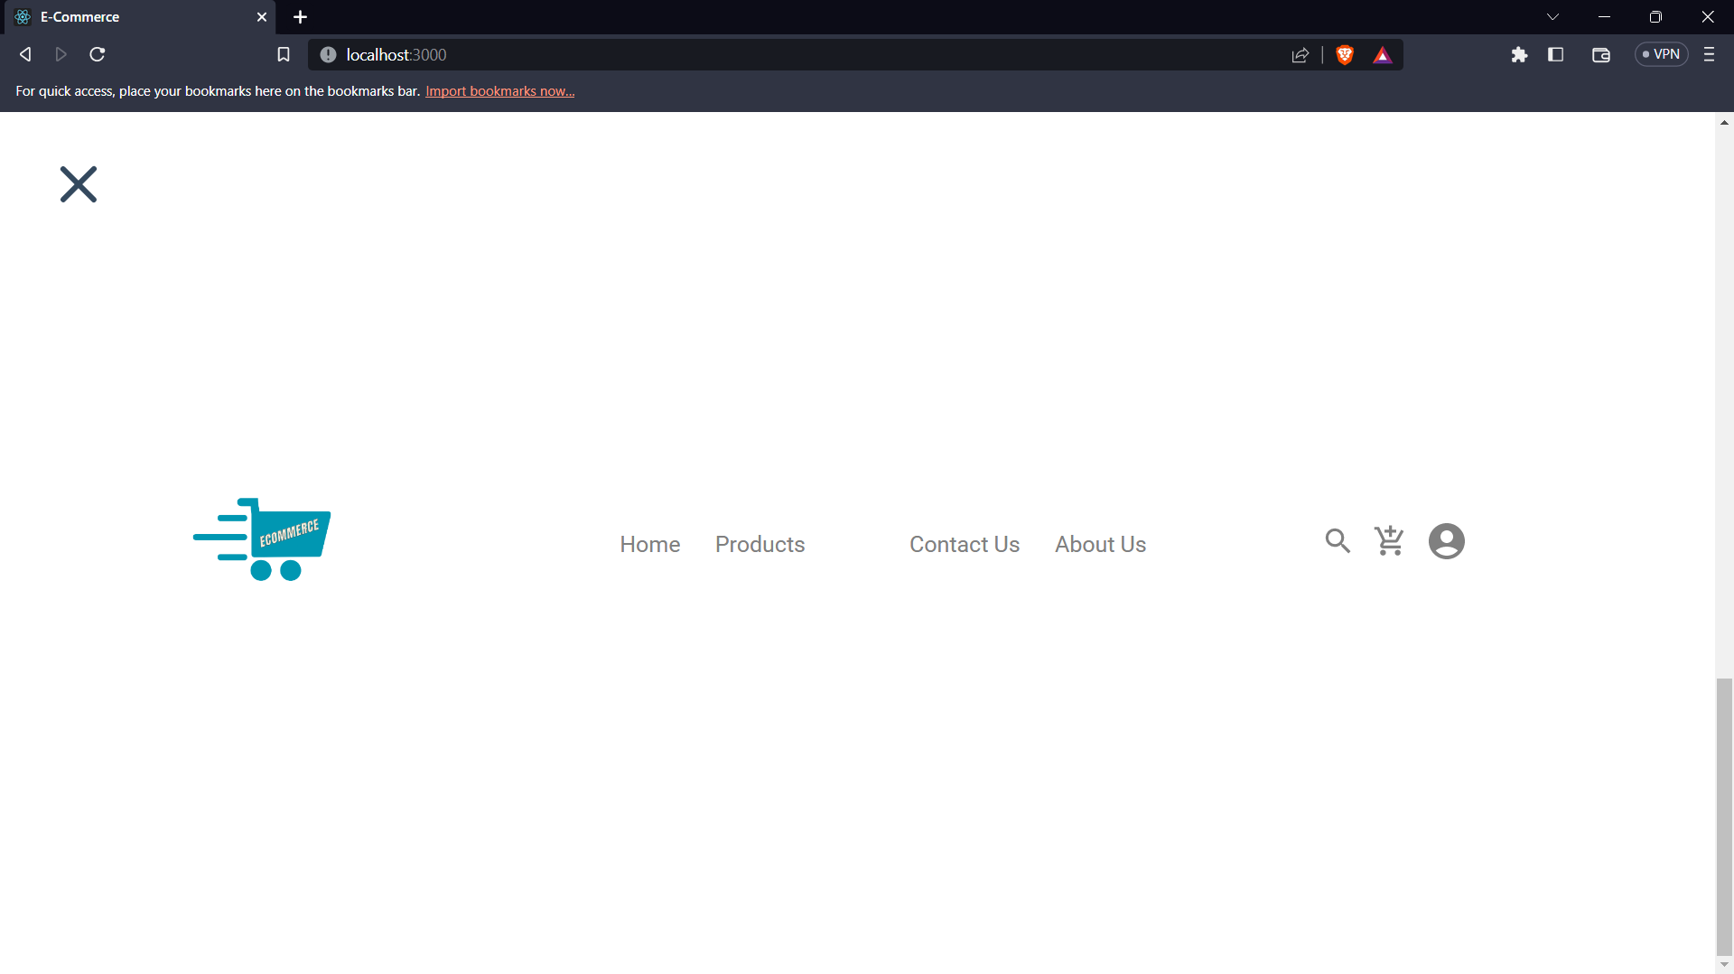

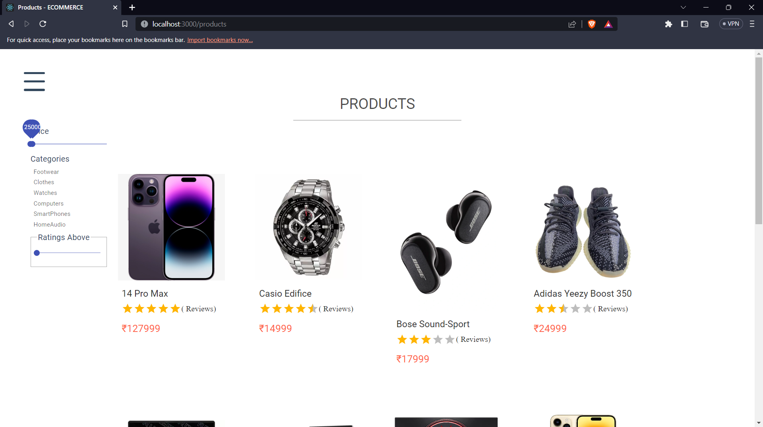

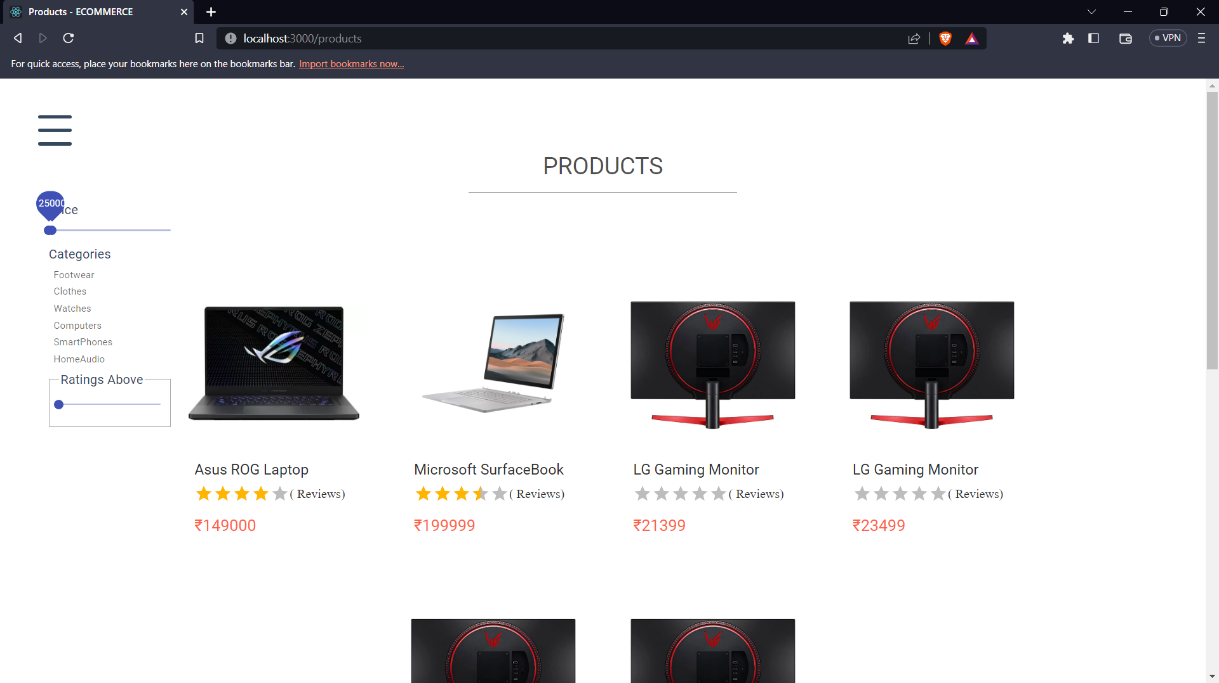

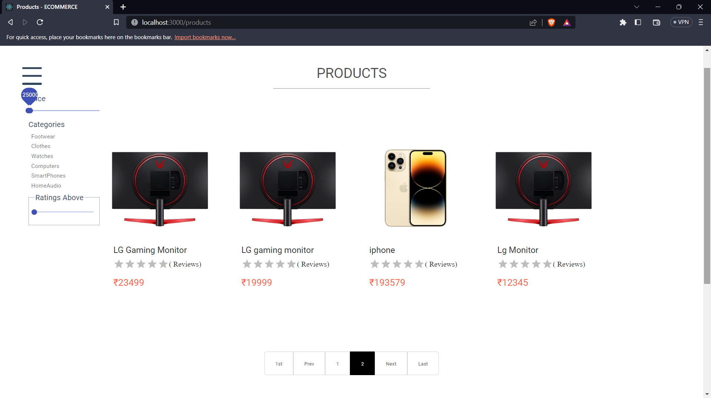

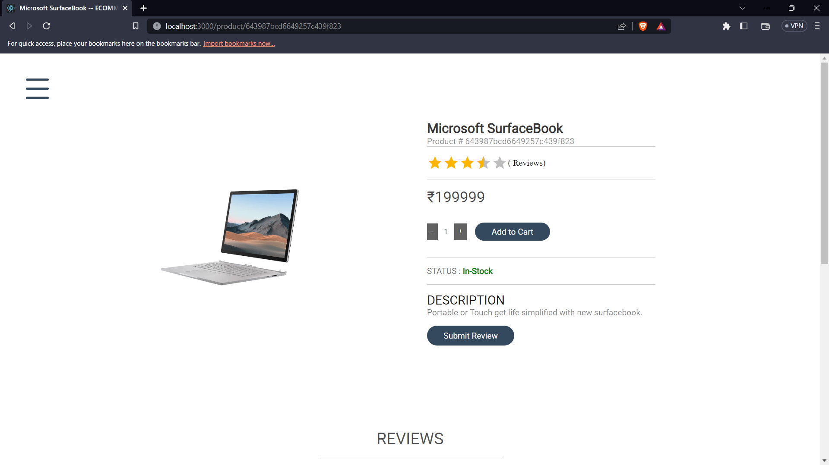

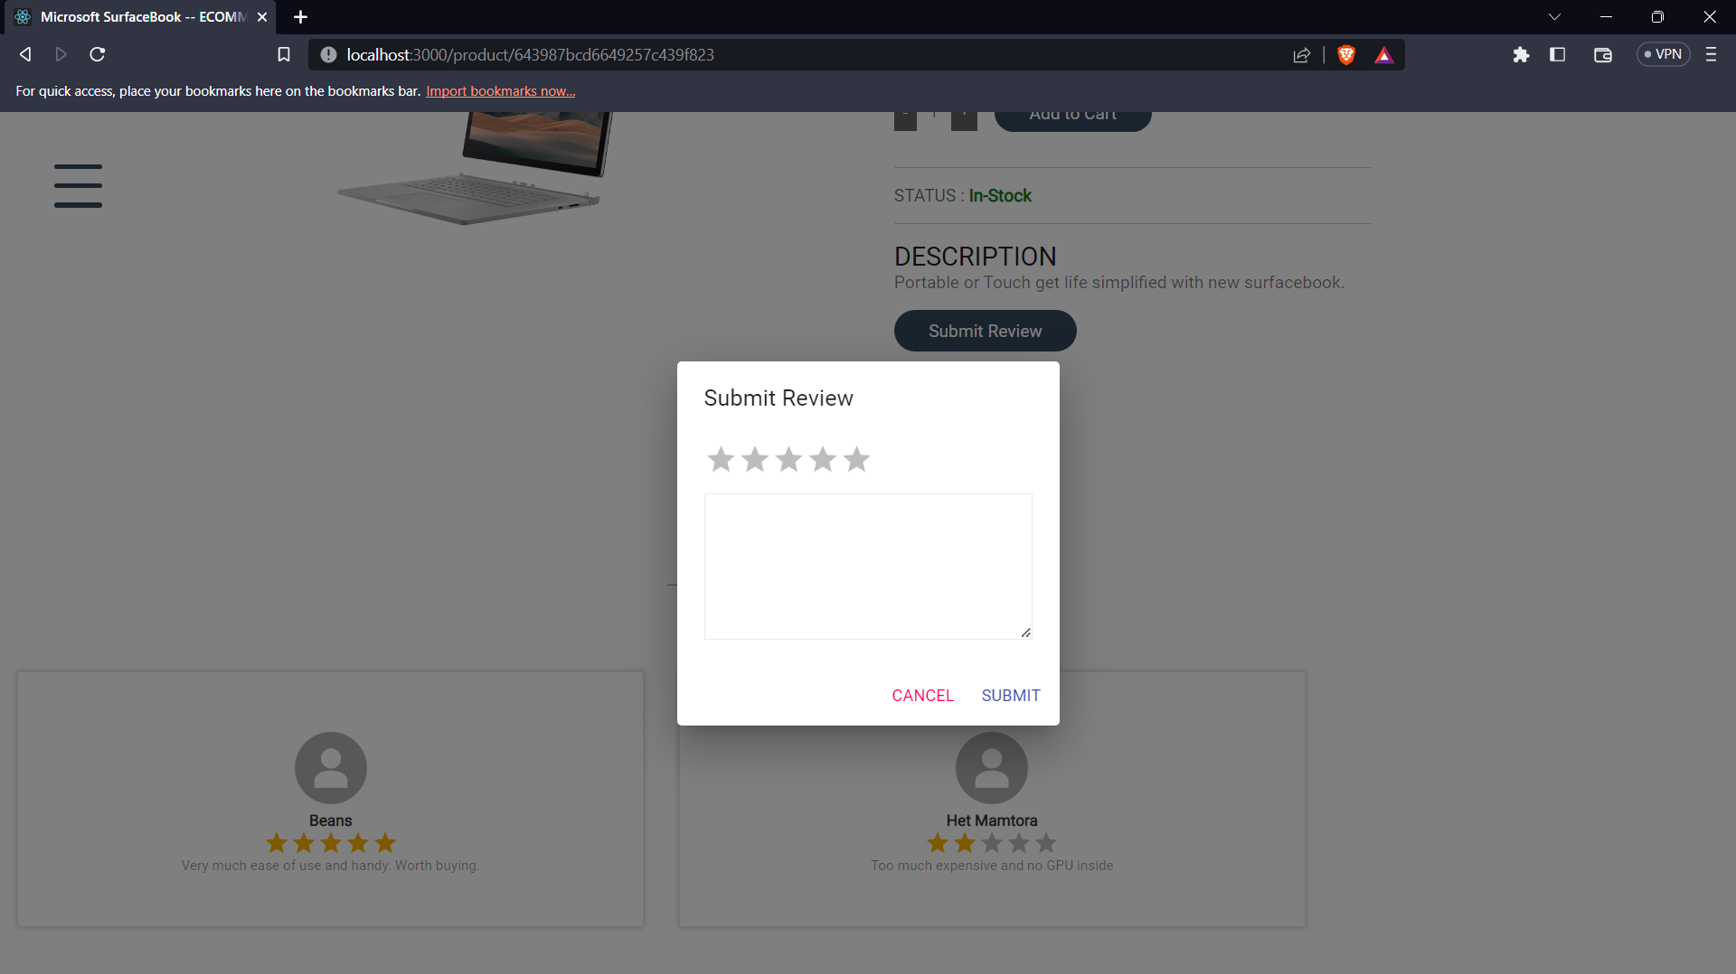

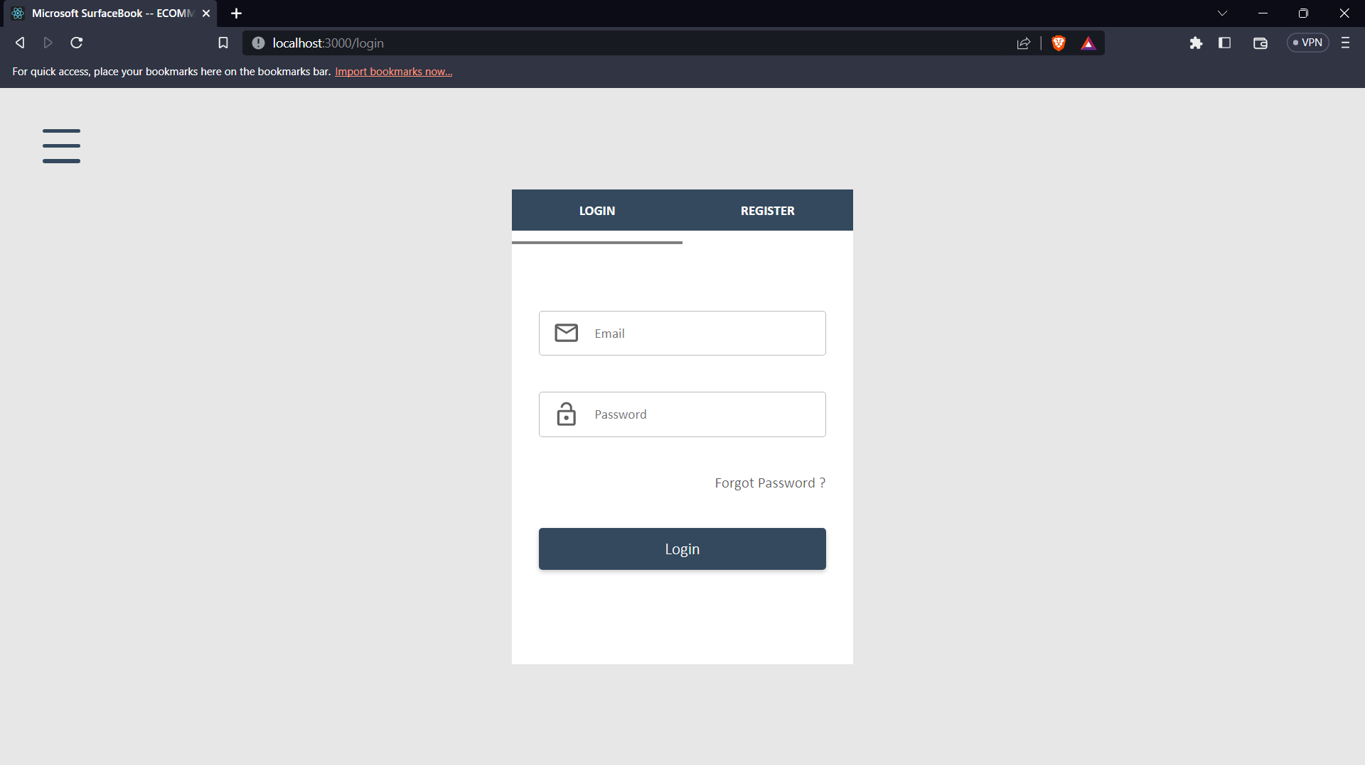

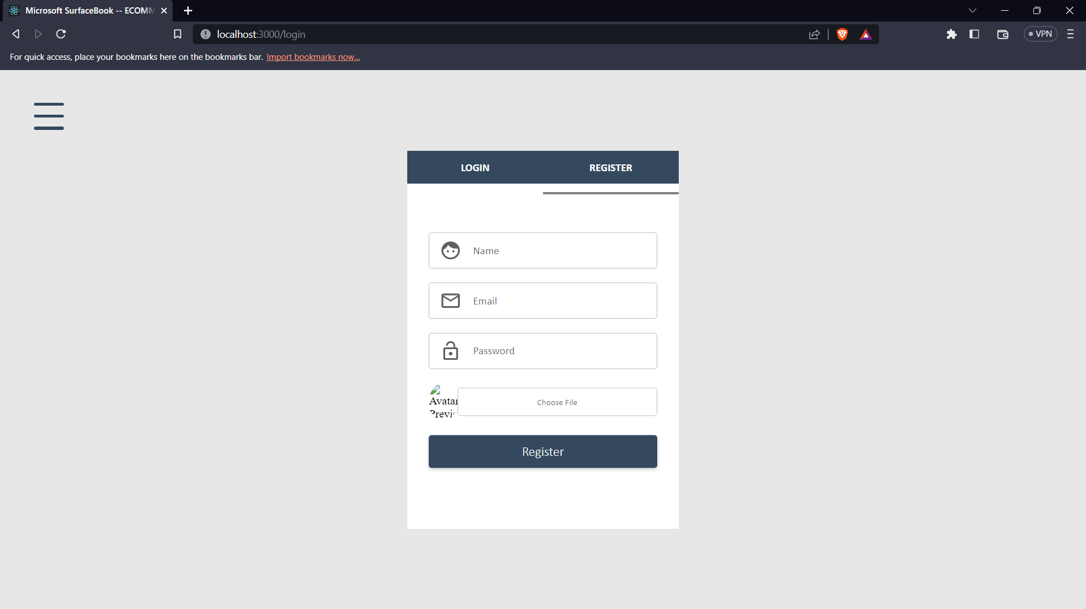

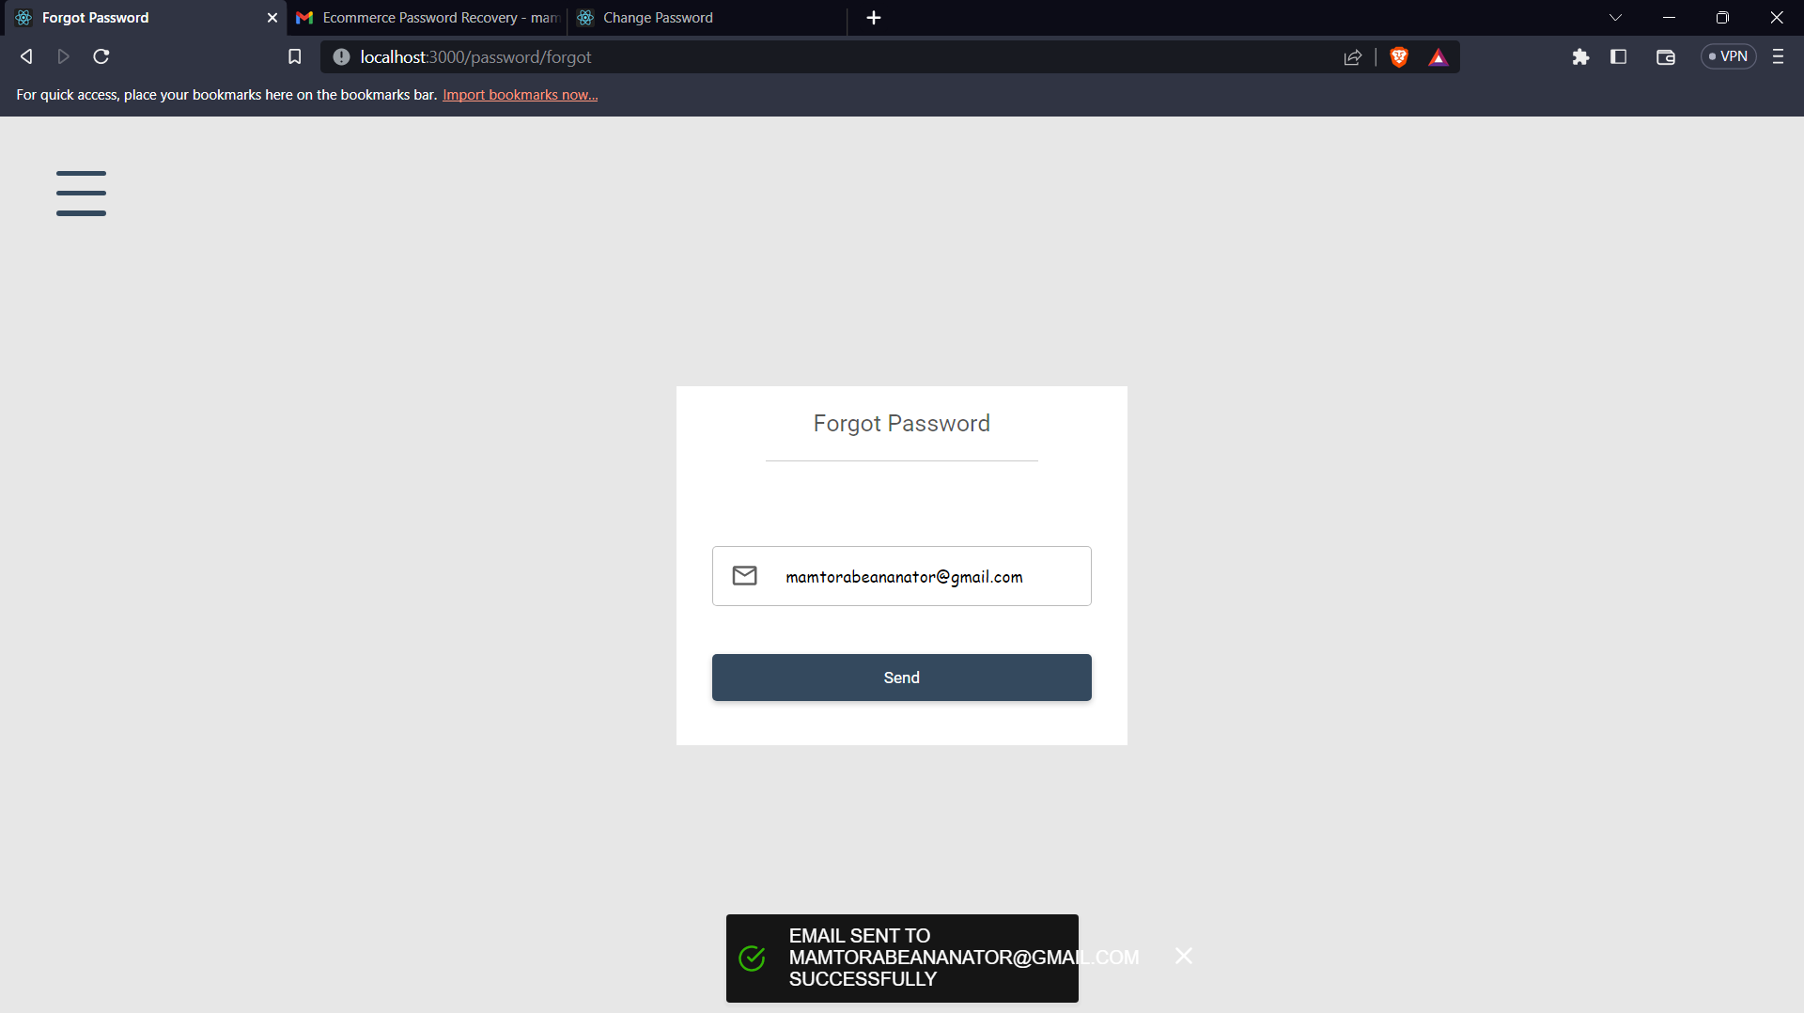

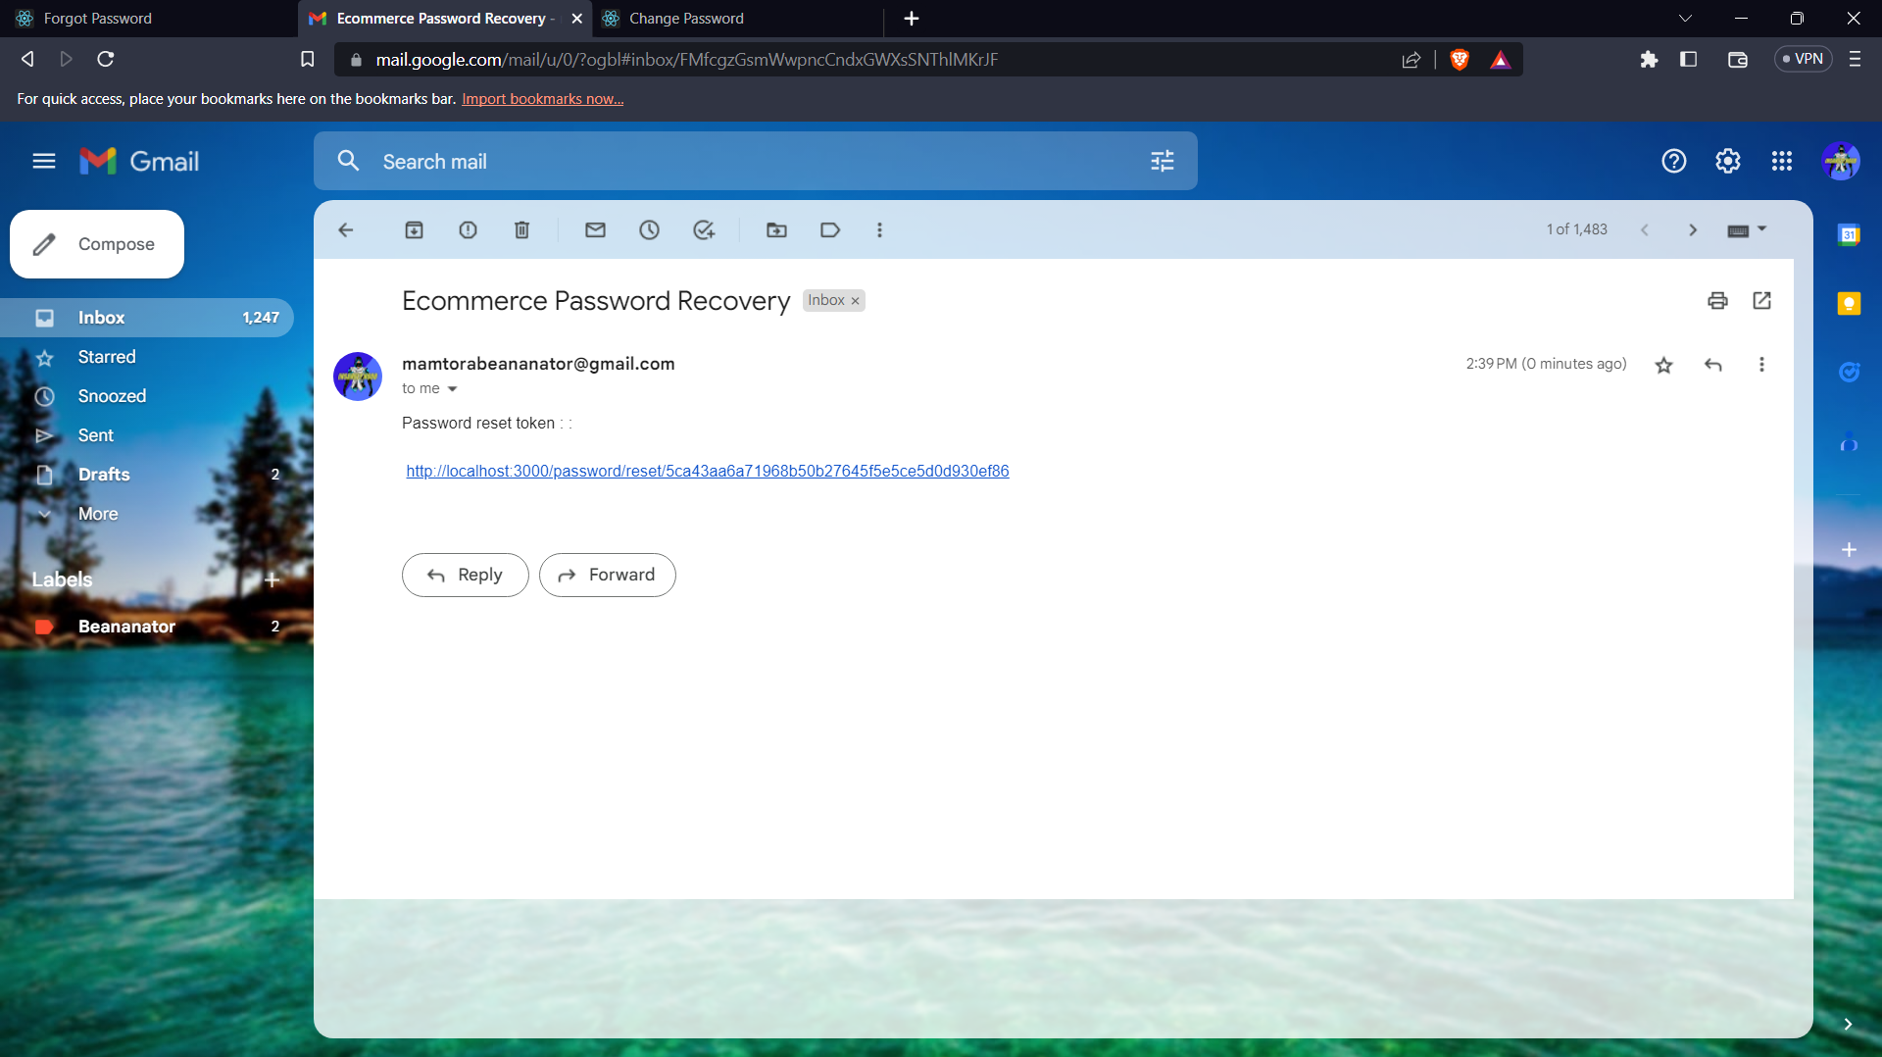

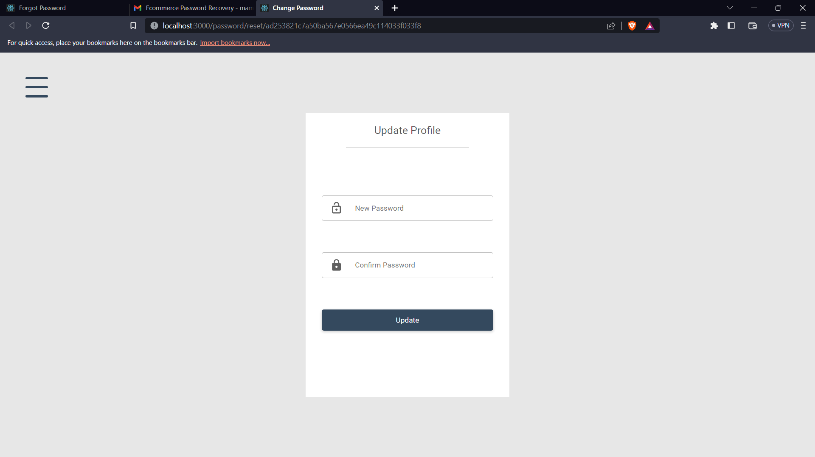

## **Admin Dashboard Functionality**

* View all products, sales and users

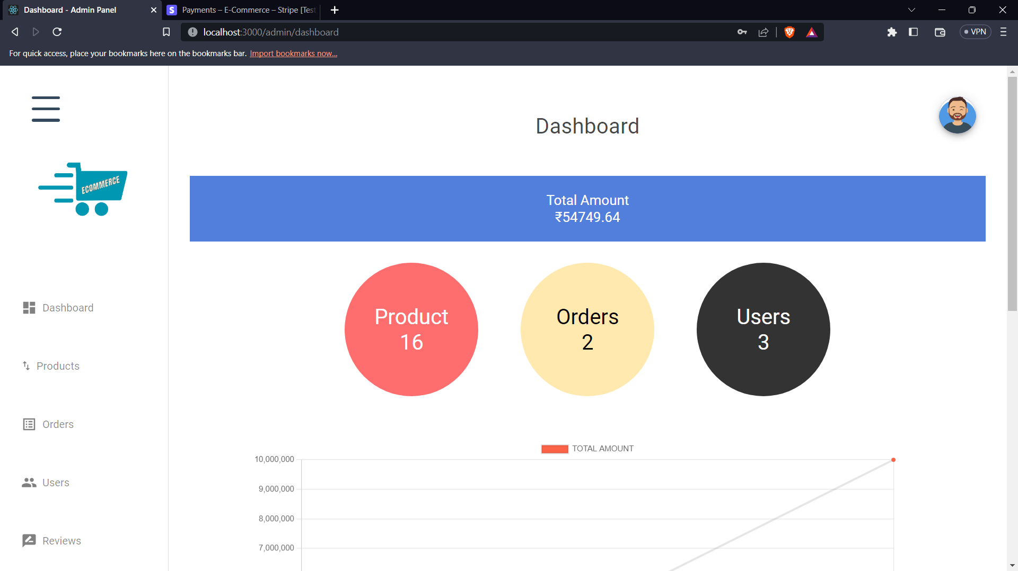

* View list of all the products

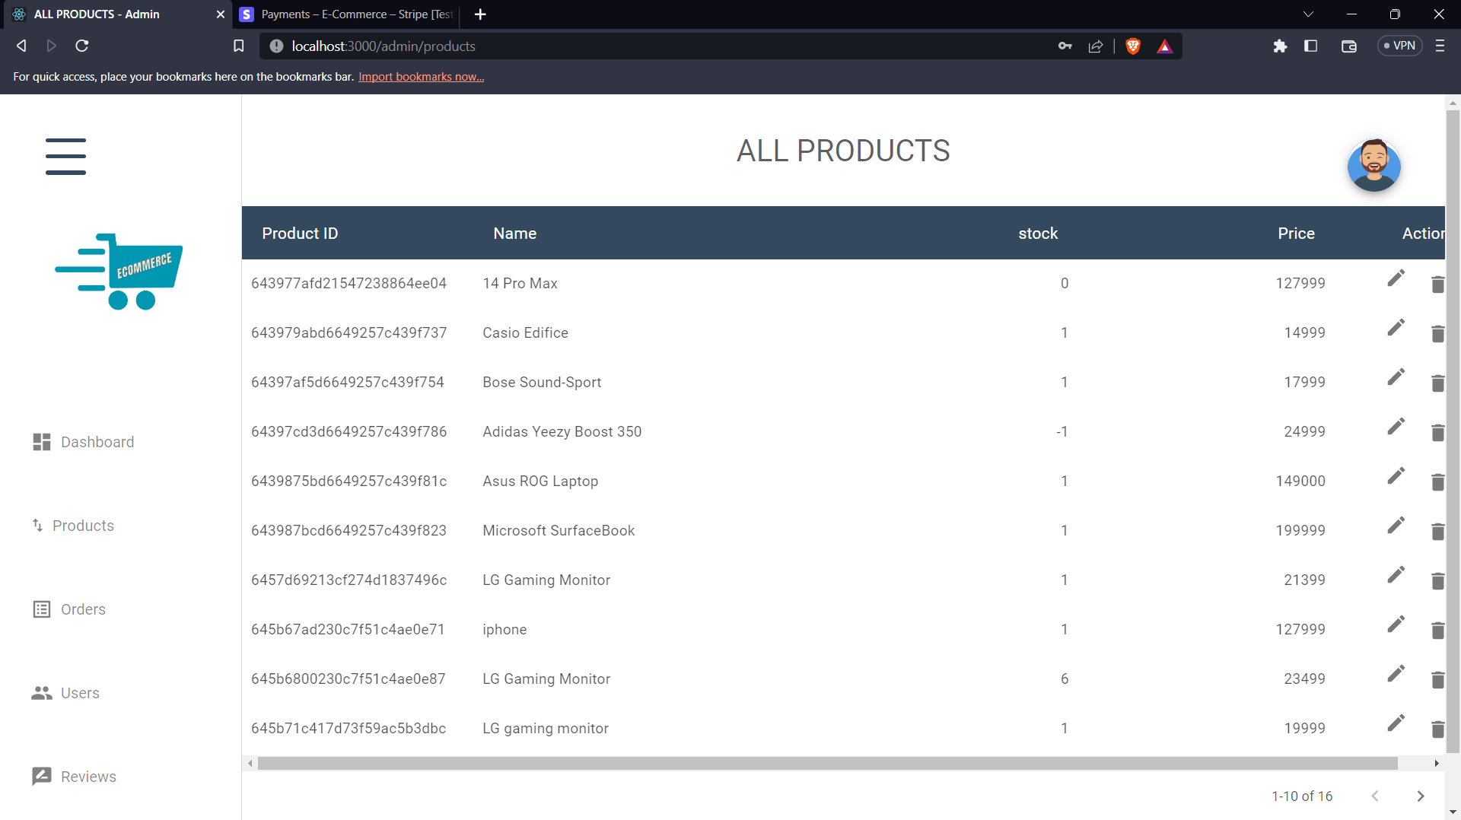

* View all orders

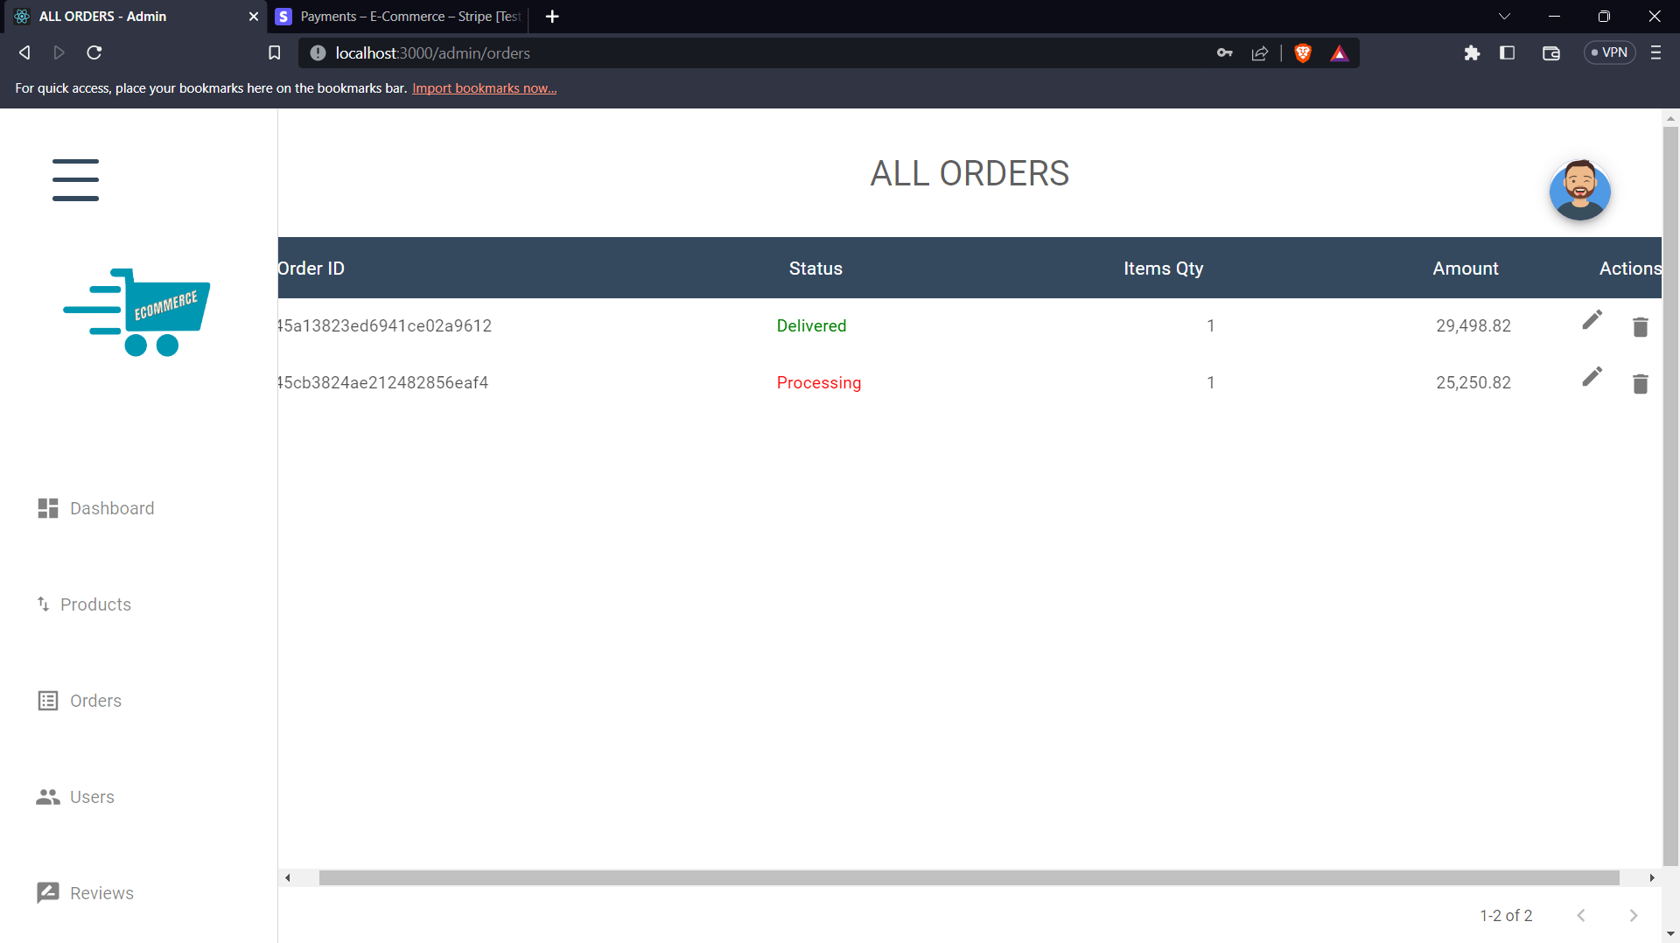

* Change Order Status

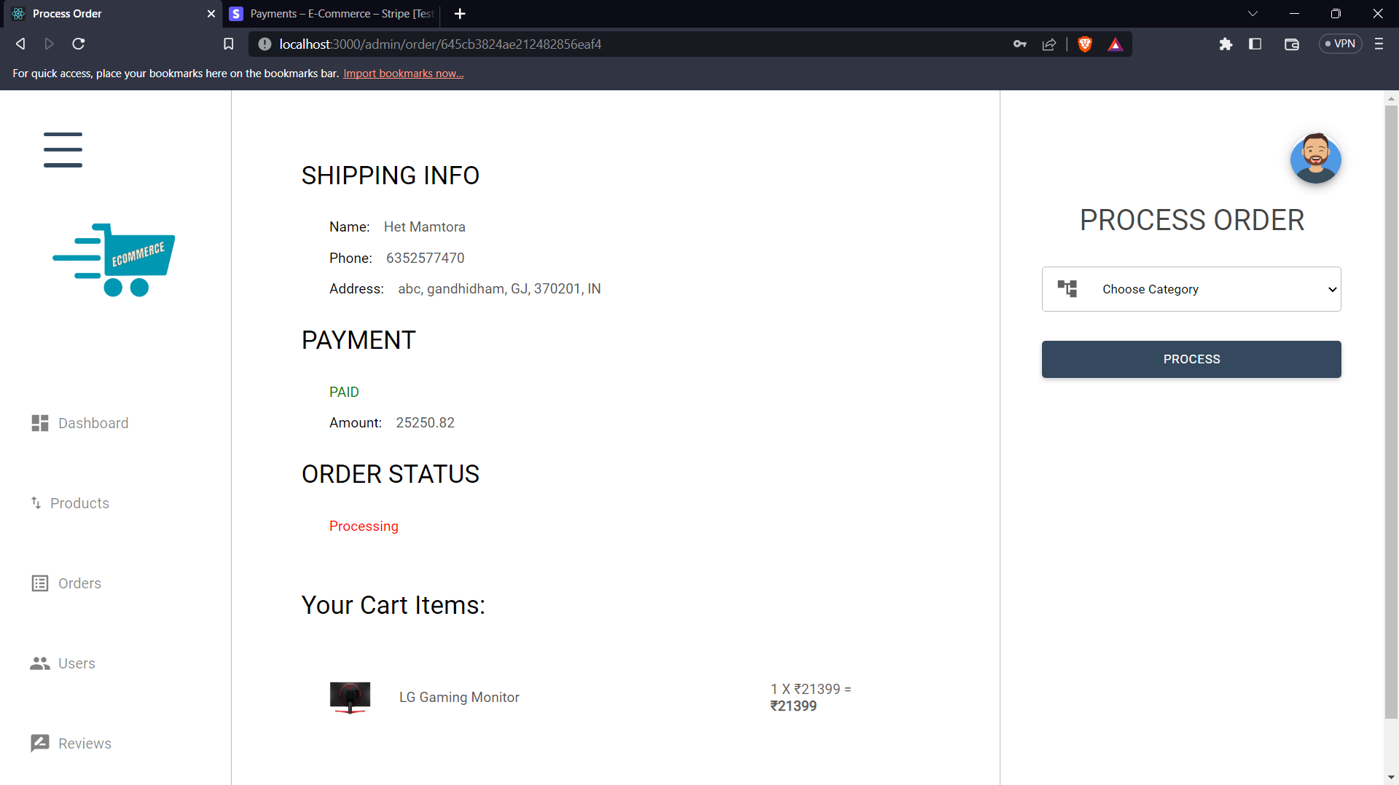

* View Users

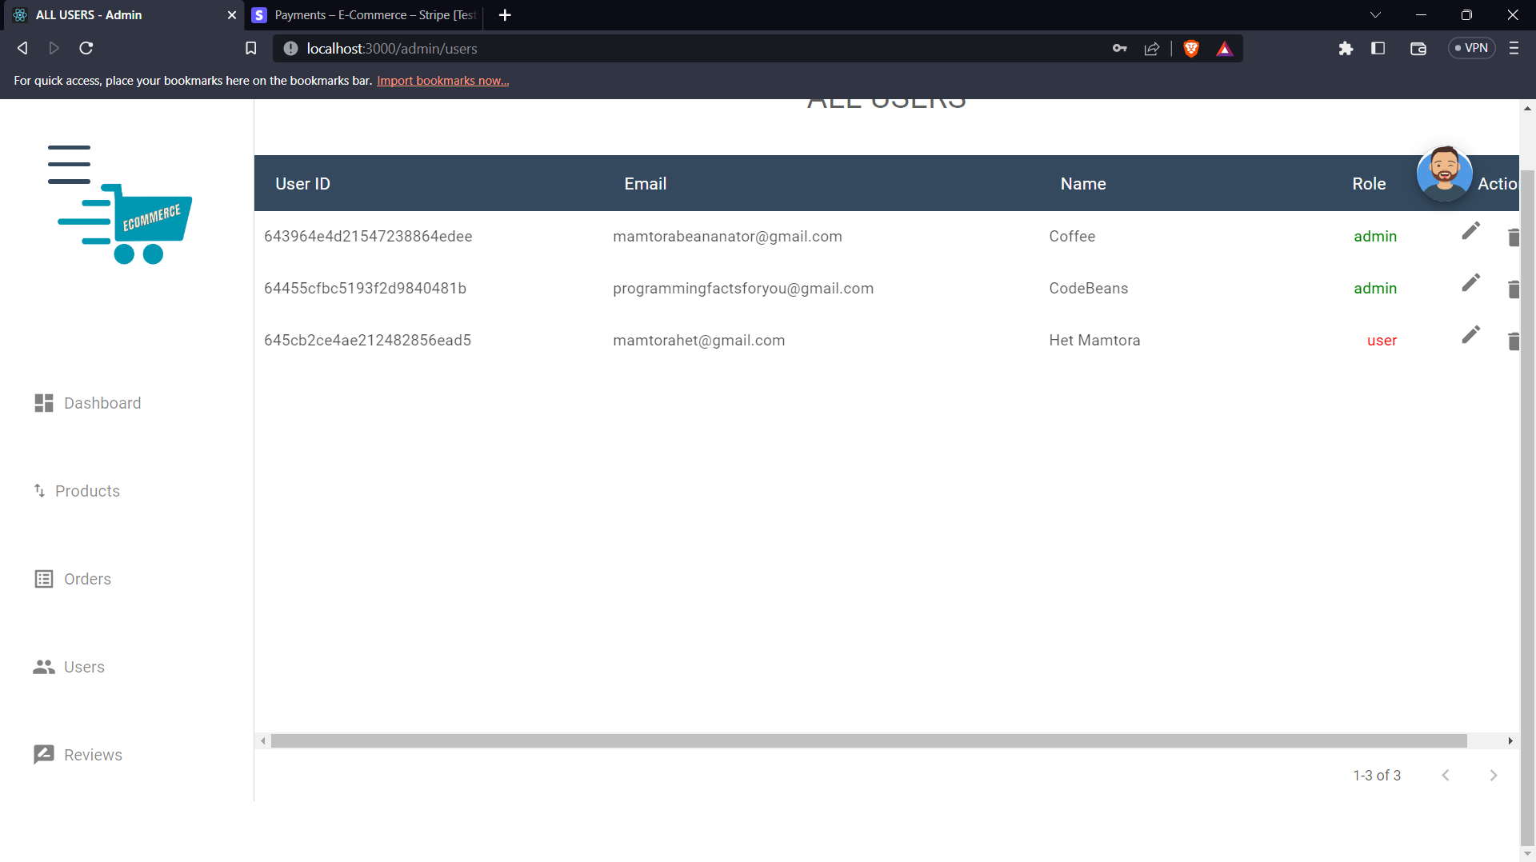

* View Reviews

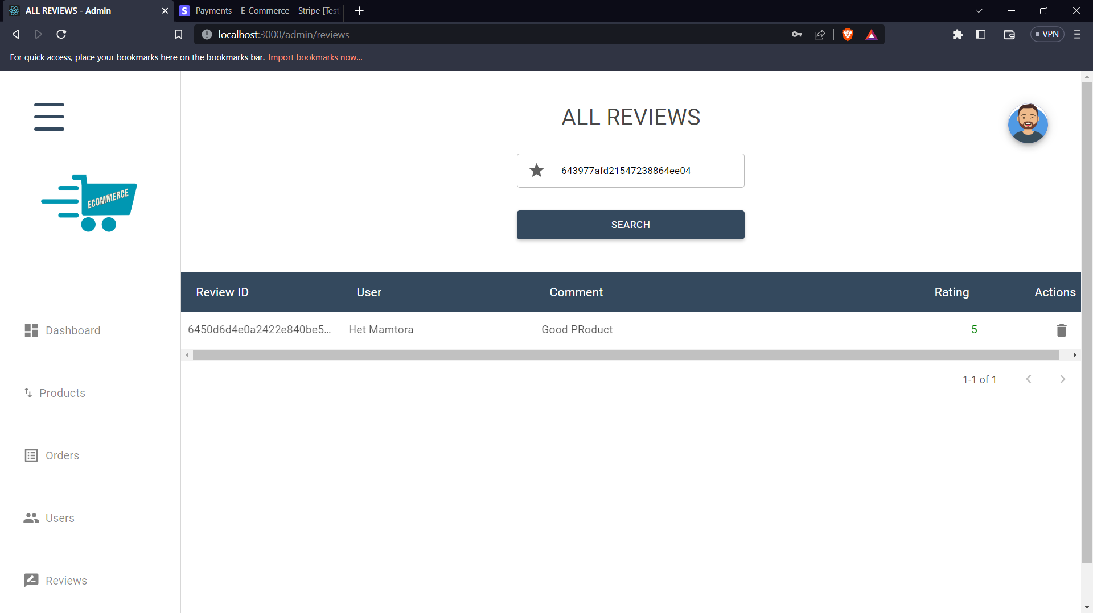

* View Payment Info on STRIPE

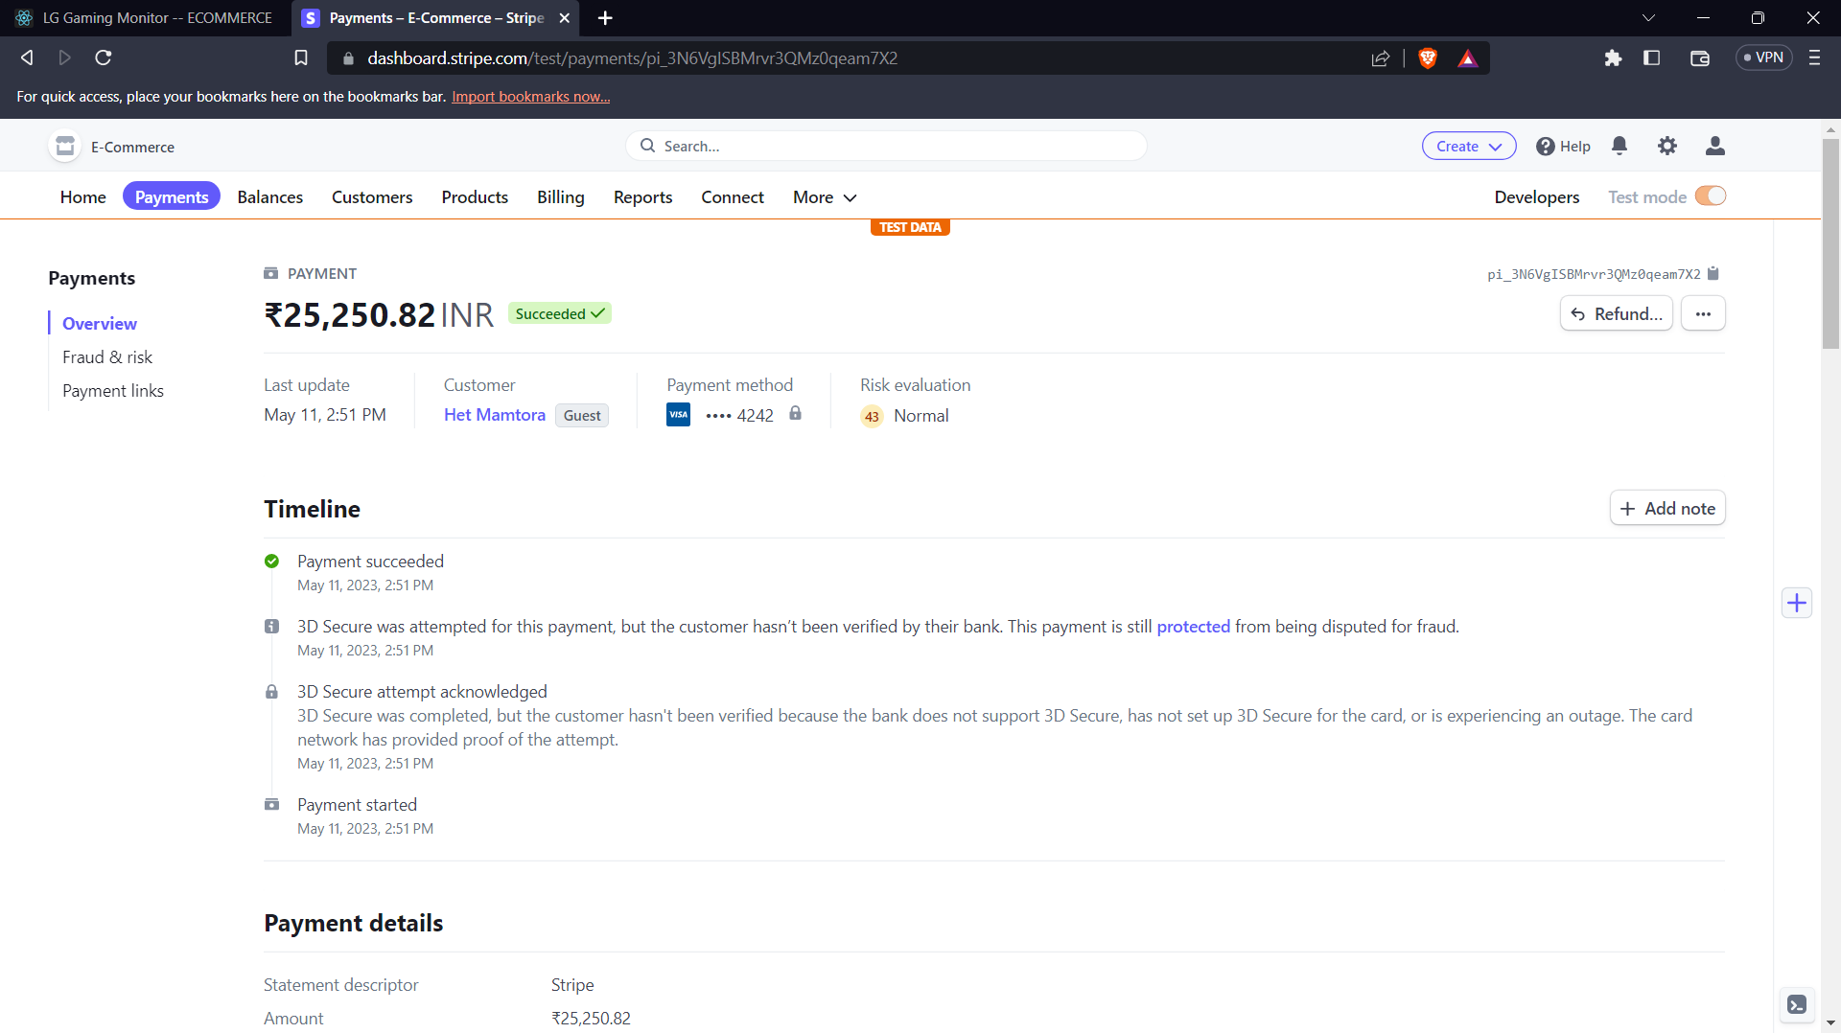

# **CHAPTER – 5: User Manual**

## **Menu Screens and Forms along With Description**

* Admin
* Create product form with cloudinary on image upload for faster retrieval of images on front end.

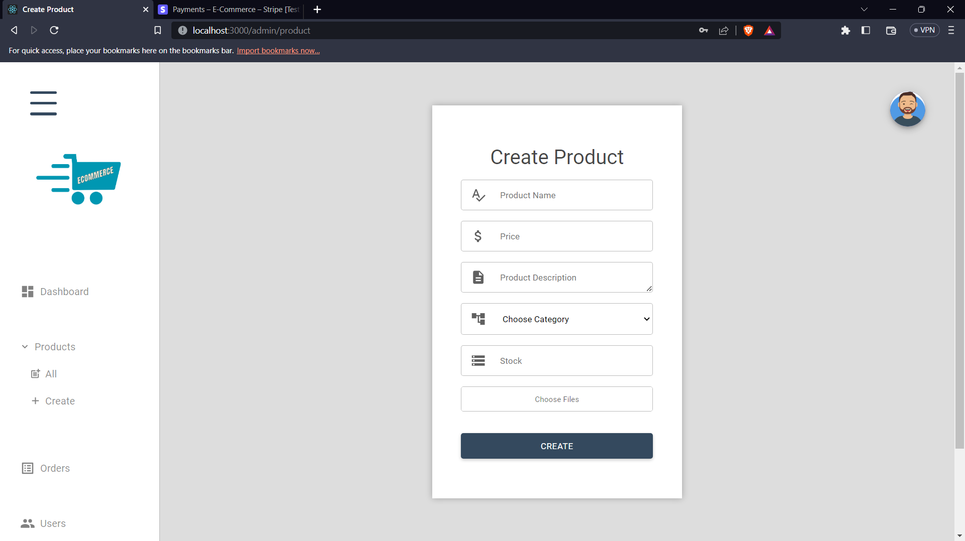

* Update product form with old data and images, new images will delete the old images from cloudinary.

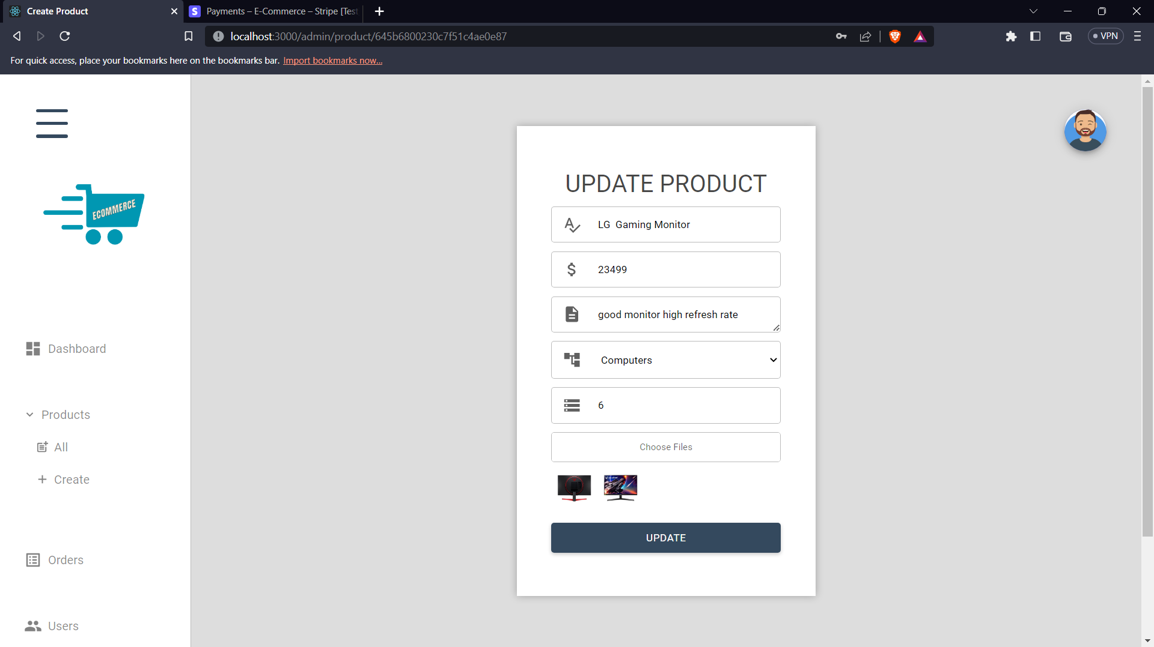

* User role update form where admin can assign admin roles to other normal users or can switch any other admin user to normal user.

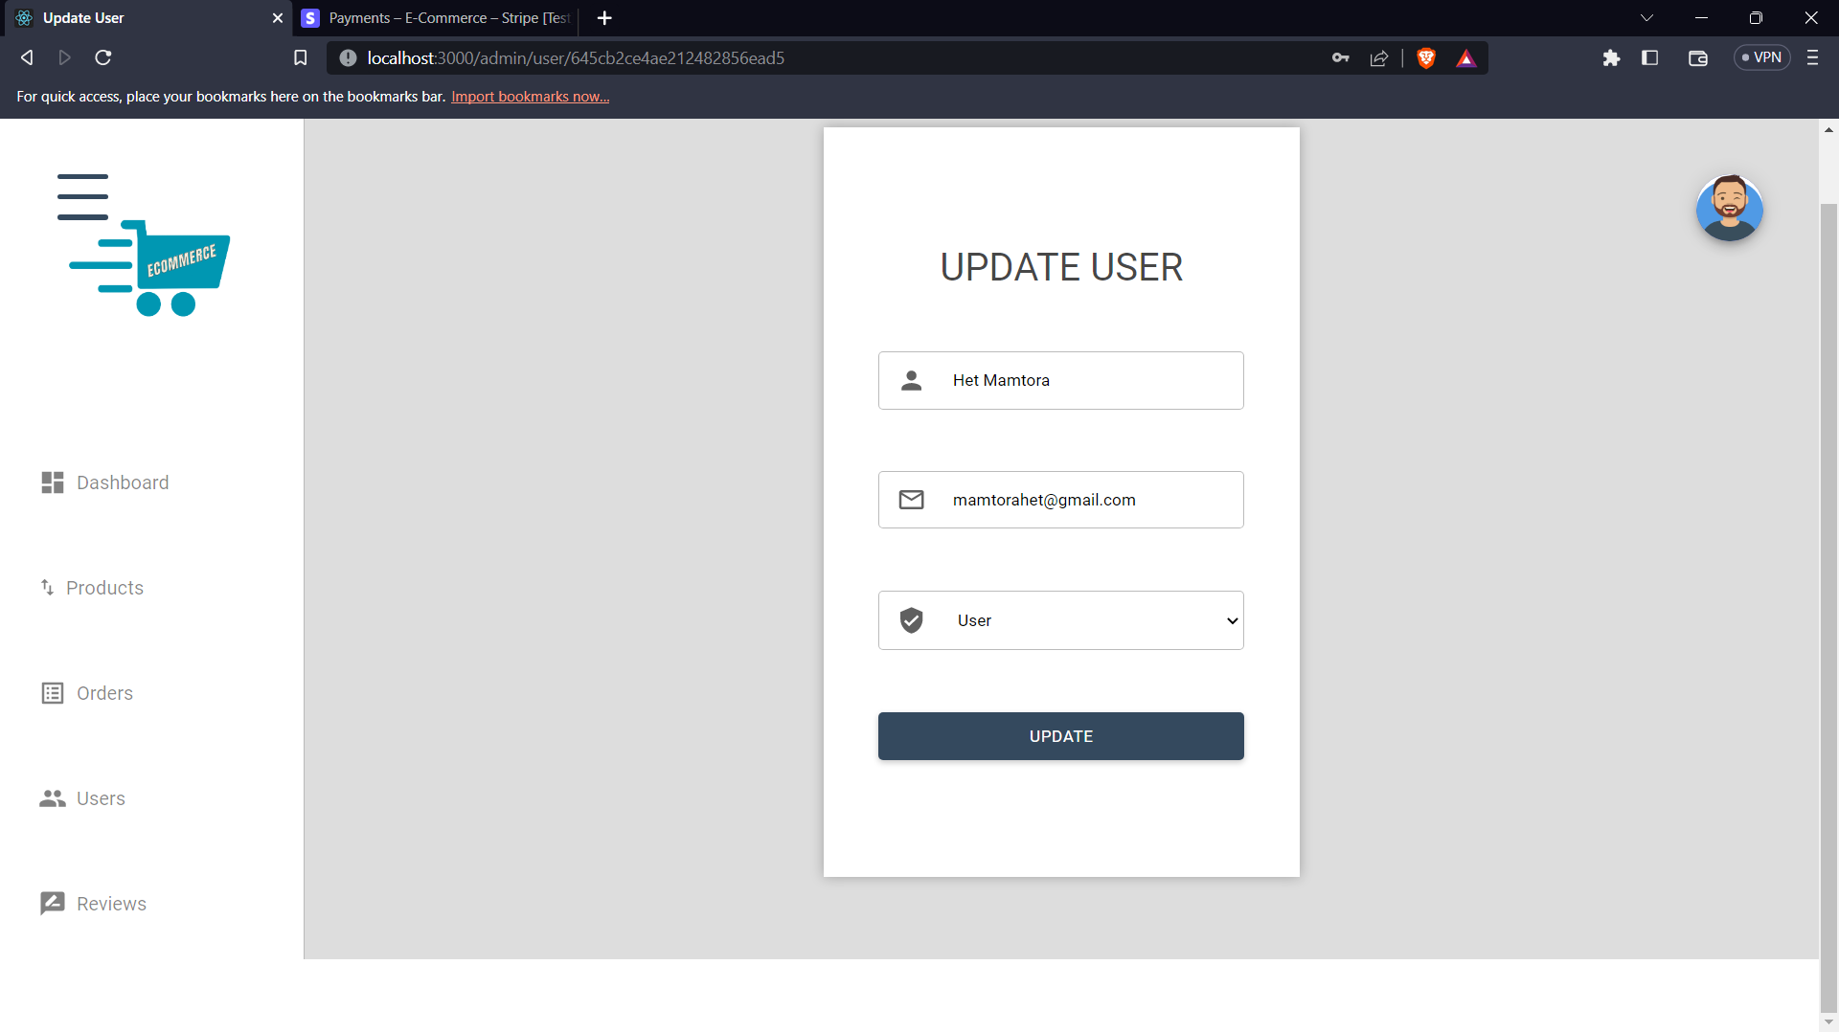

* User
* User has to fill required details in registration form to make account and gain access to buying portal of the web application.

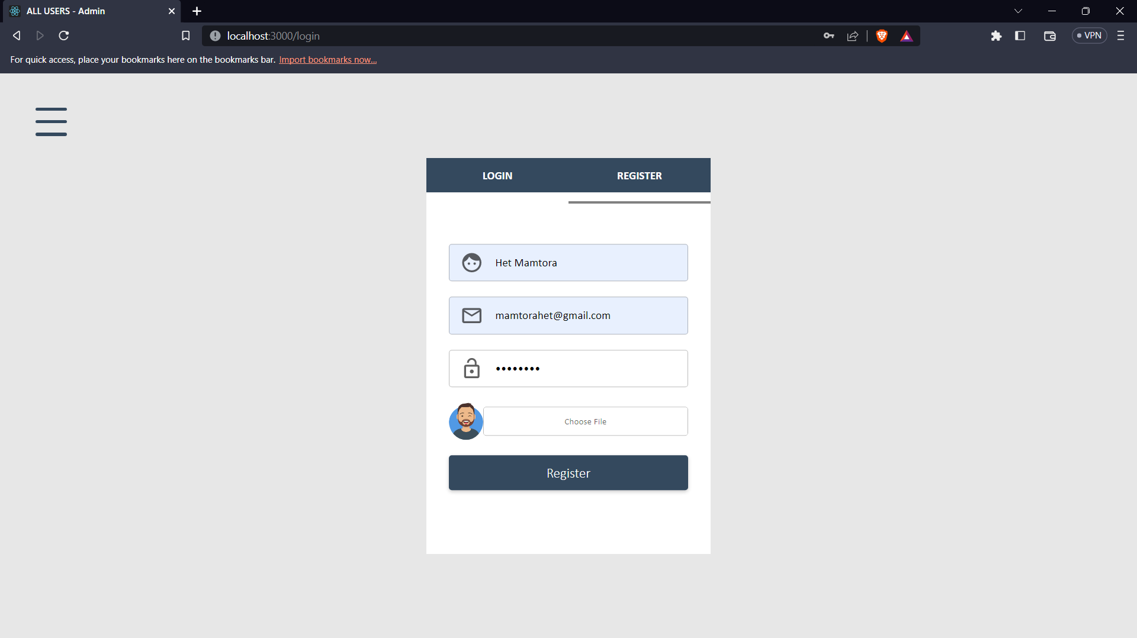

* After the registration is complete user can use email and password to login into the application.

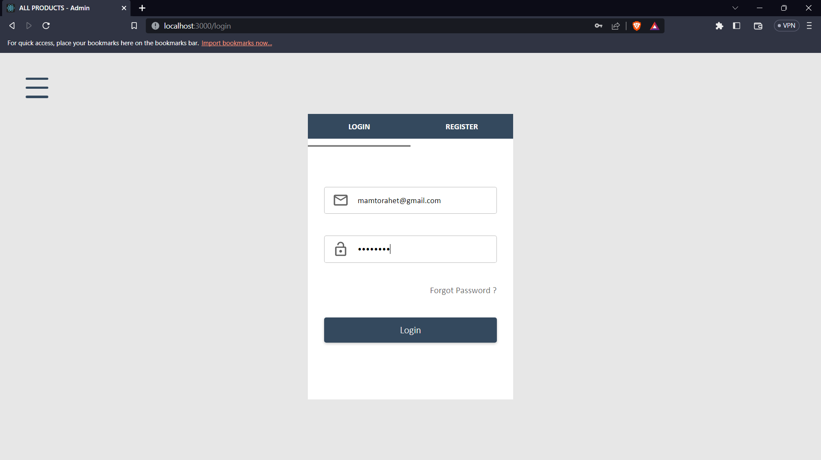

* From accounts page user can update profile look into the previous orders and change the password.

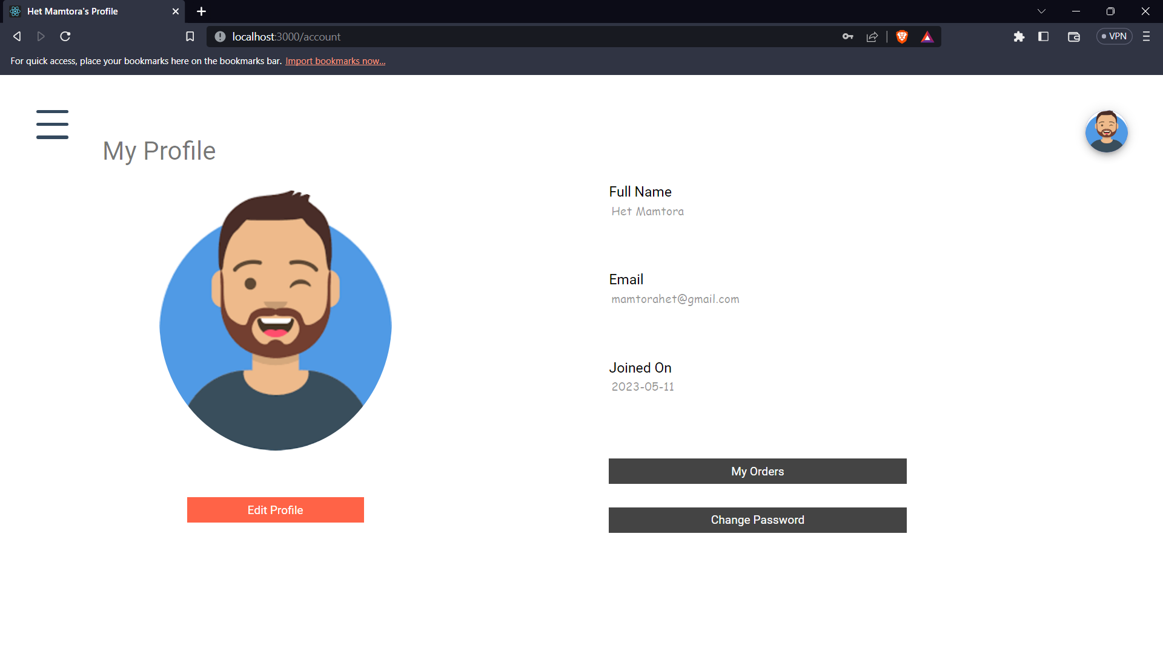

* Logged-In / Guest user can view and add products into cart but cannot checkout unless a user is logged in.

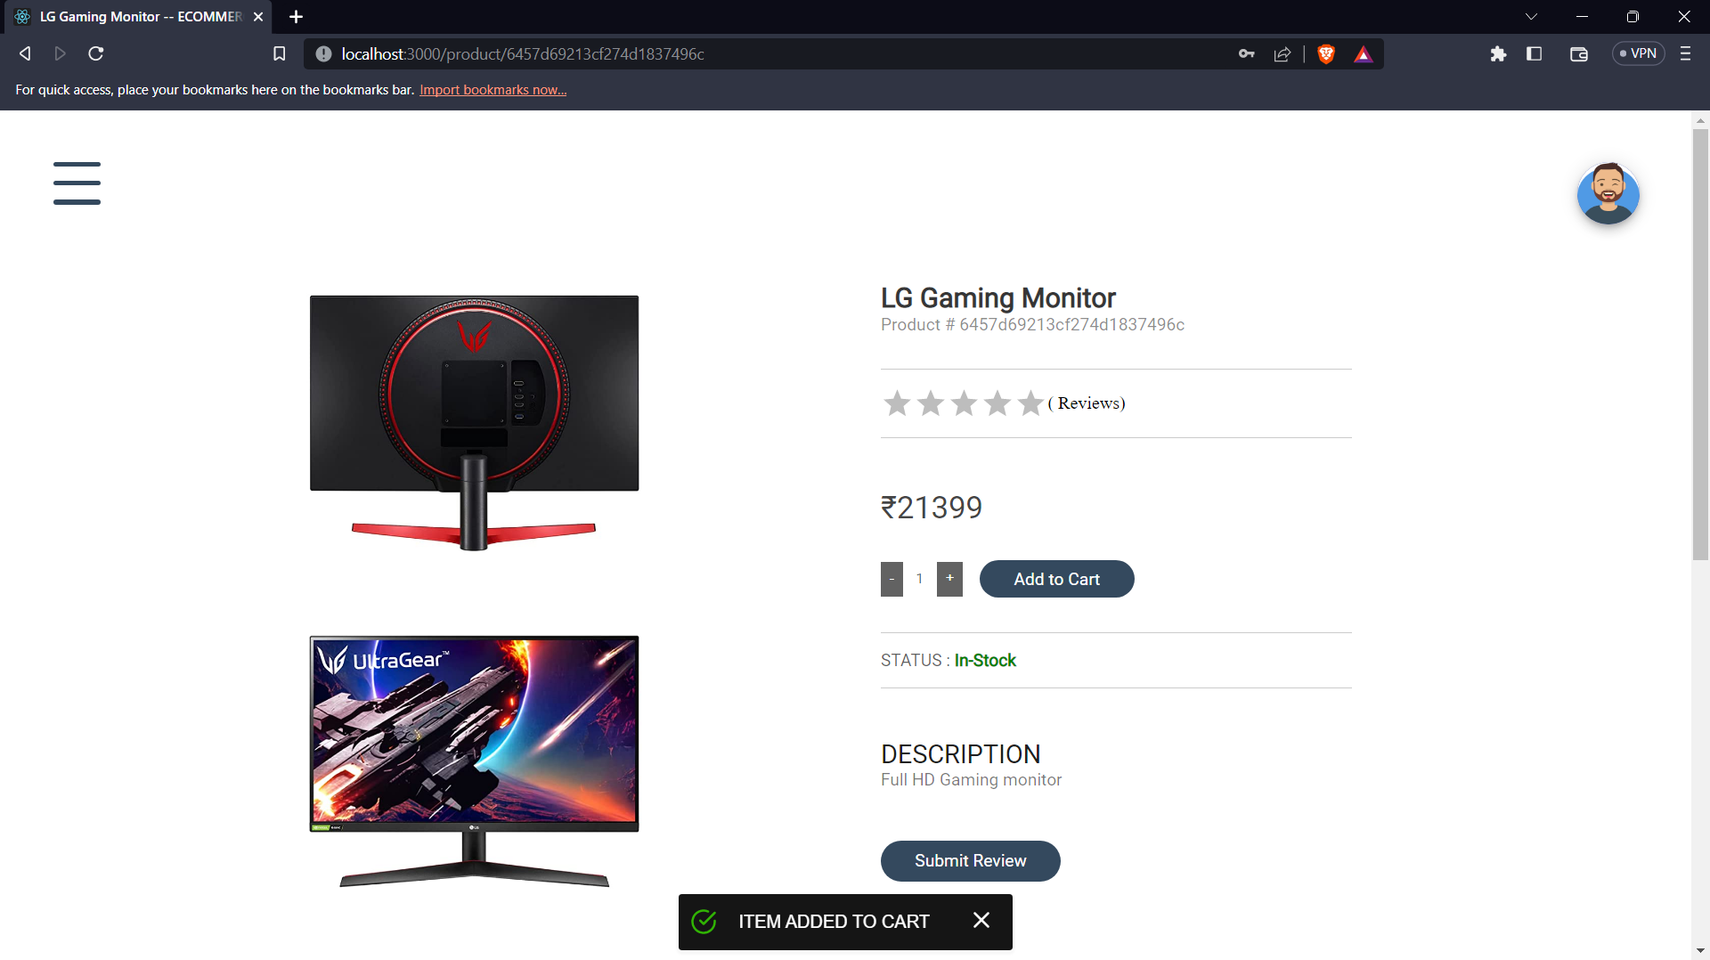

* Check out page is redirected through cart page after checking if the authenticated user is logged in or not.

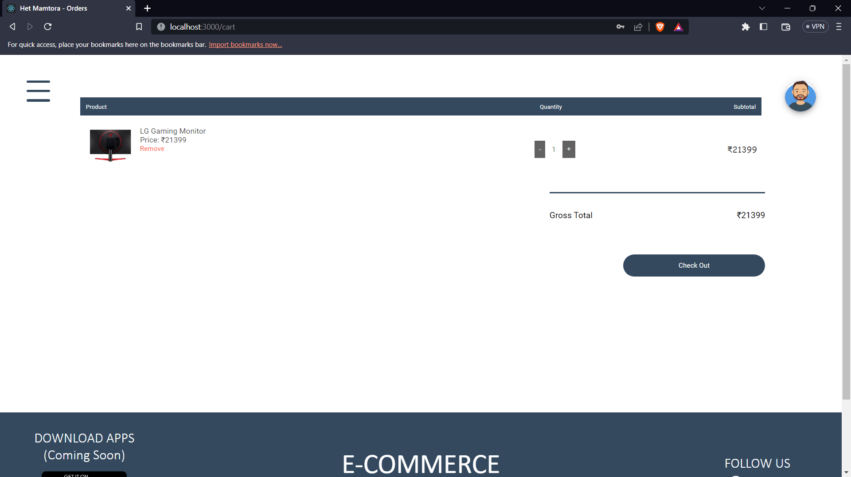

* Enter all the shipping details and users can select the country of their living according to which the states will be suggested in the state select options. Then click on continue to process to order confirmation.

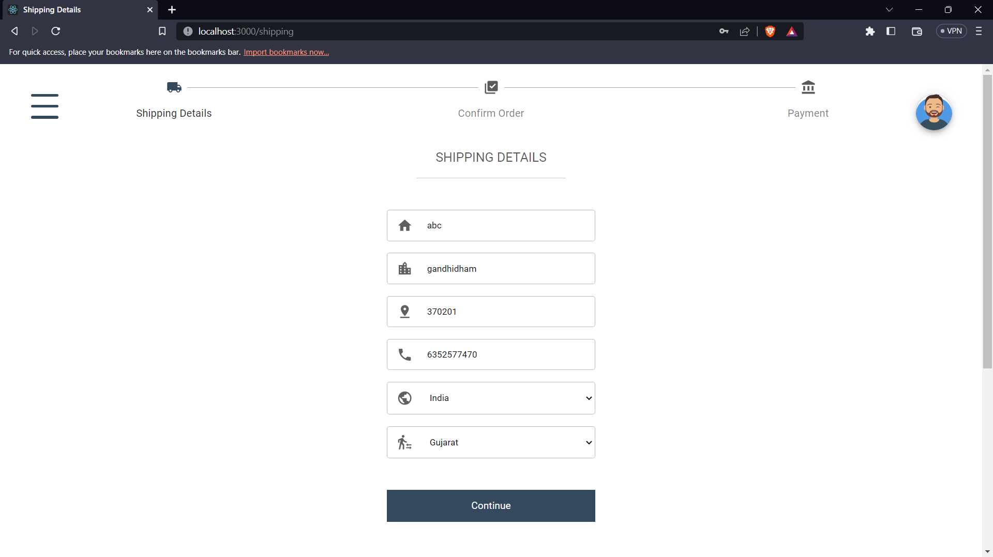

* This page gives the whole summary of the order which is to be placed by the logged in user. Then click on Proceed to Payment to provide payment details.

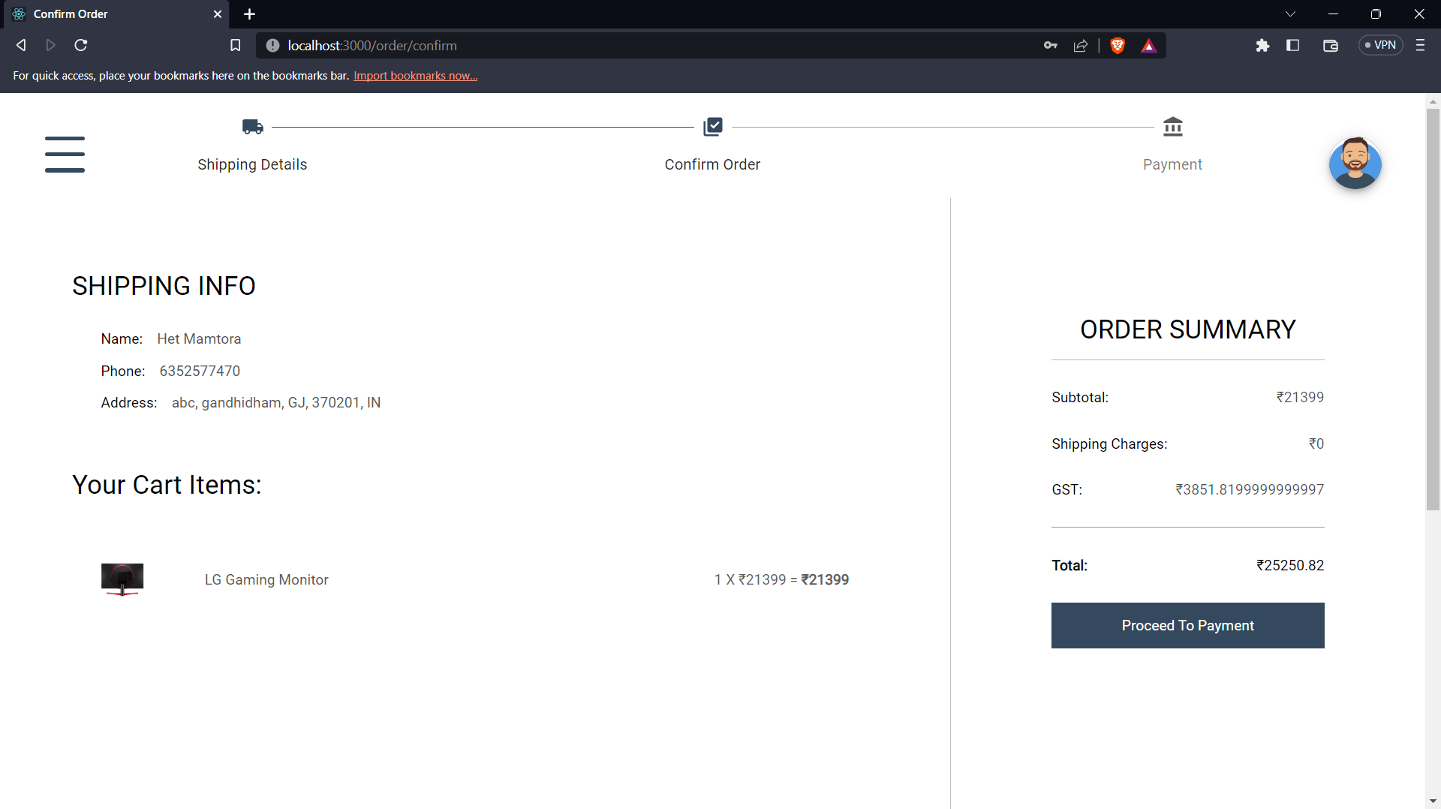

* As the payment gateway is all managed by strip API user can use multiple payment options of debit or credit card as stripe supports almost all of the platforms of card payments.

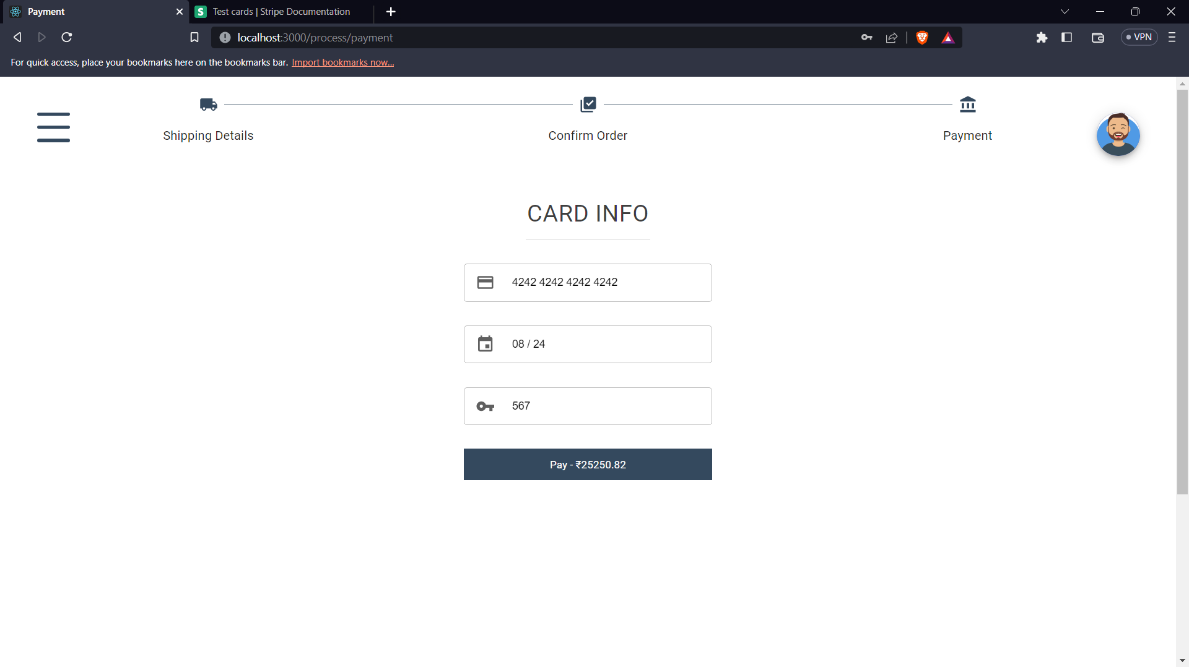

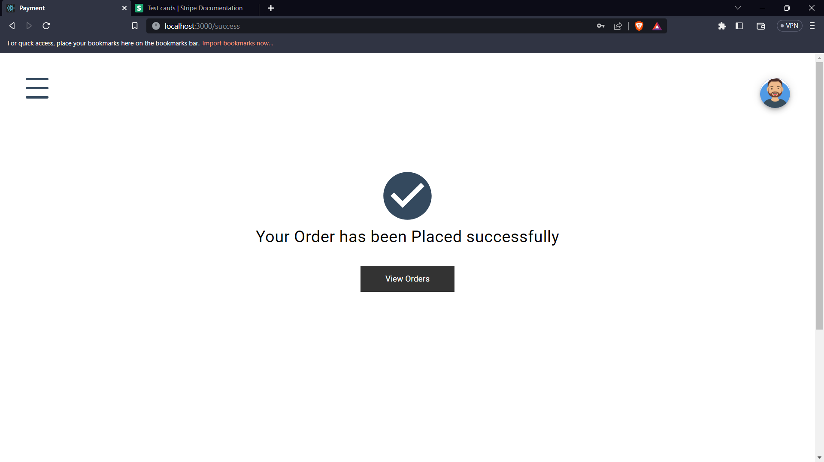

* By clicking on View Order user can see list of all the current and previous orders which were made on this portal.

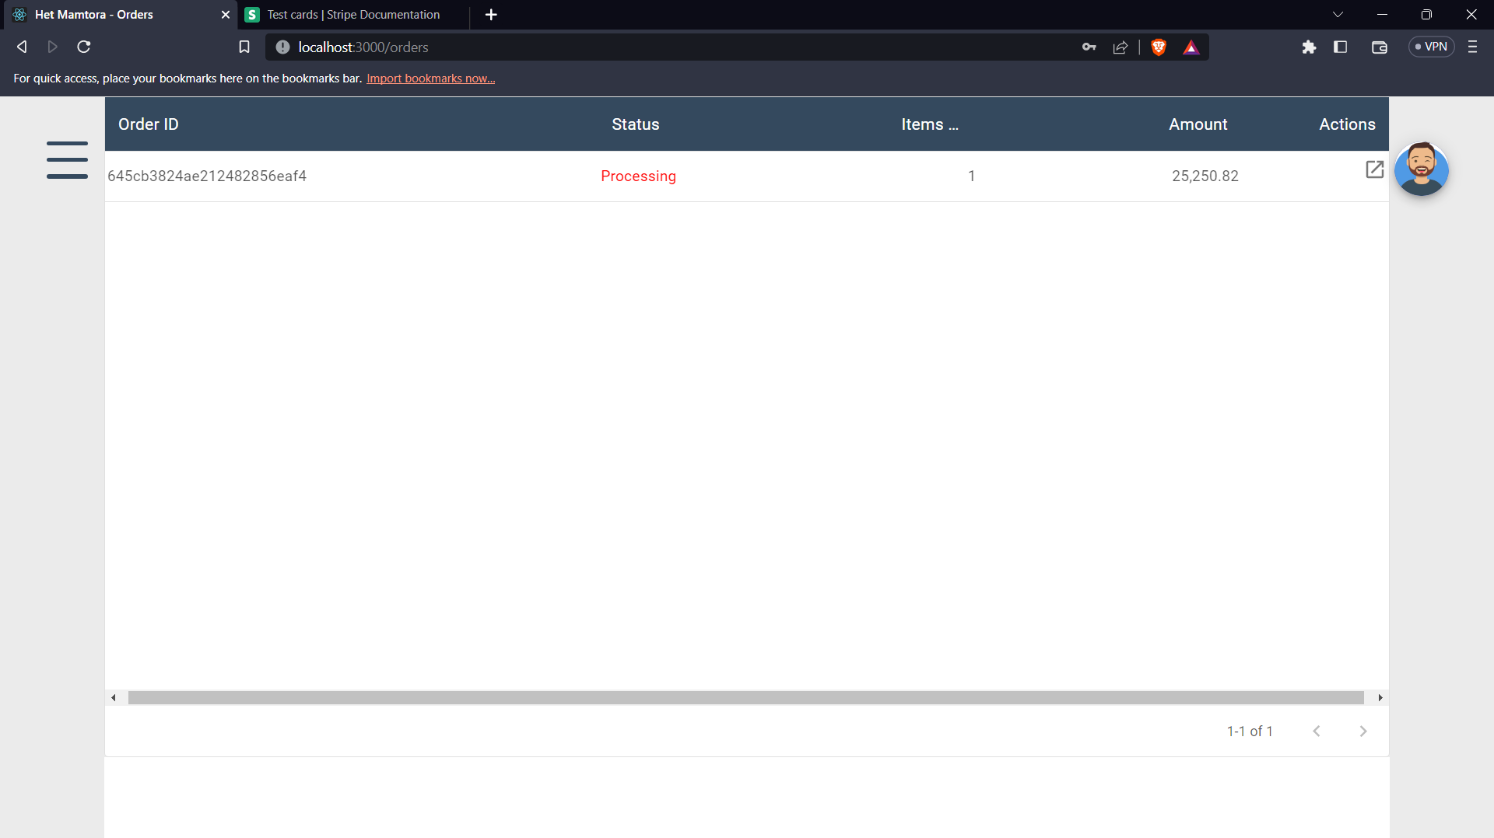

* By clicking on actions icon user can view the status of the order that the order had already been shipped or is still under processing.

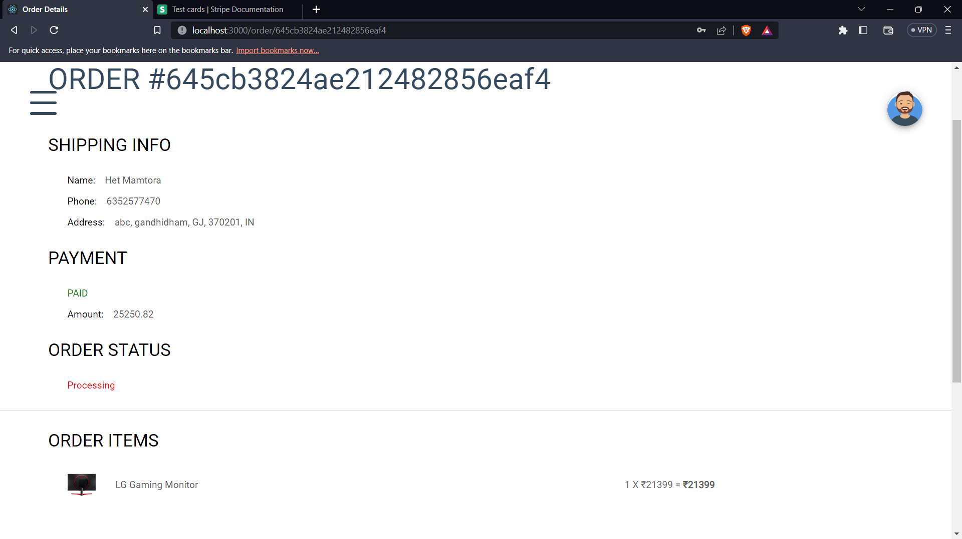

# **CHAPTER – 6: Testing**

## **Importance of Testing**

Testing is the procedure through which a system is used with human created input to verify whether or not it is correctly operating and producing the required results.

System testing procedure is used to test system experimentally to ensure that the software does not fail at any point of time during the execution. In other words system will run according to its specifications and in the way users expect it to run and produce outputs. Special test data are input for processing and the results are examined.

During testing limited number of users are allowed to use the system or portal so that the analysis can be brought into picture on how efficiently the system is working and performing for the end user. This testing is carried out in two phases namely Unit testing which is done for each component independently on its completion and other one is system testing which is done at the end of the whole project.

## **API Routes Testing**

This API Routes testing are completely validated using postman where all the page data fetching is validated according to the different API and id’s which are passed along with it.

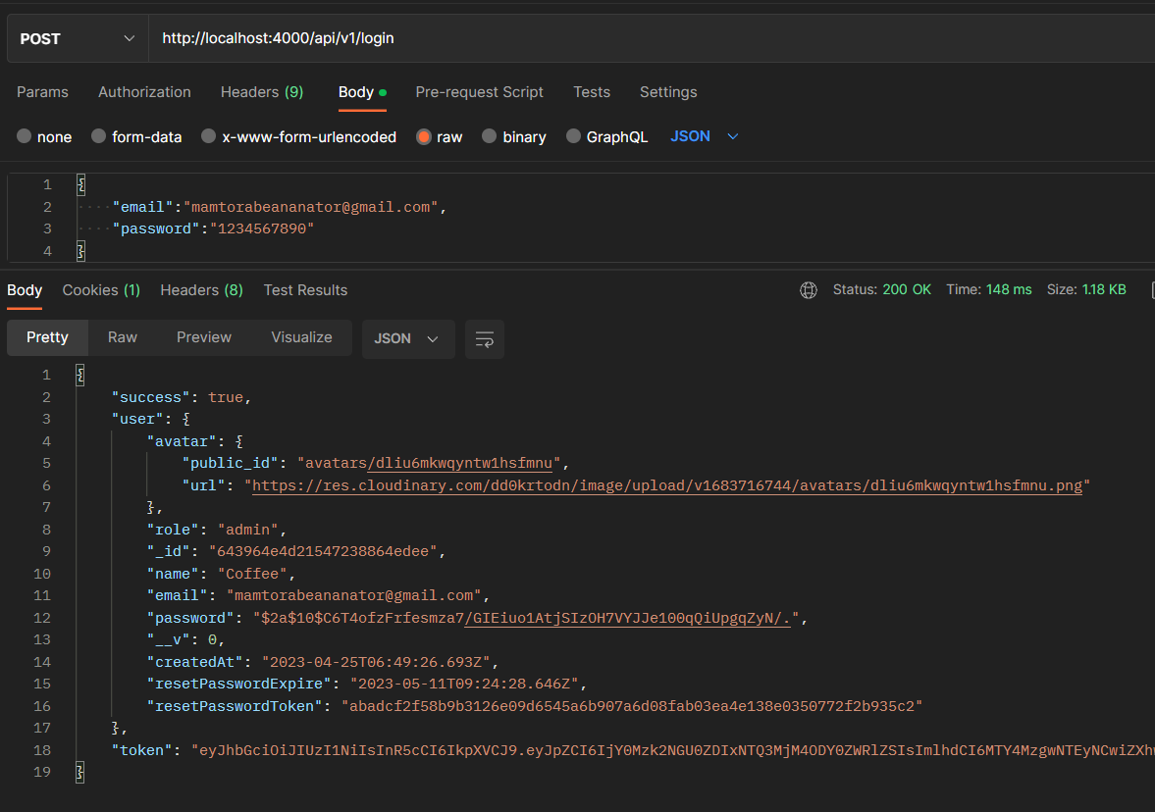

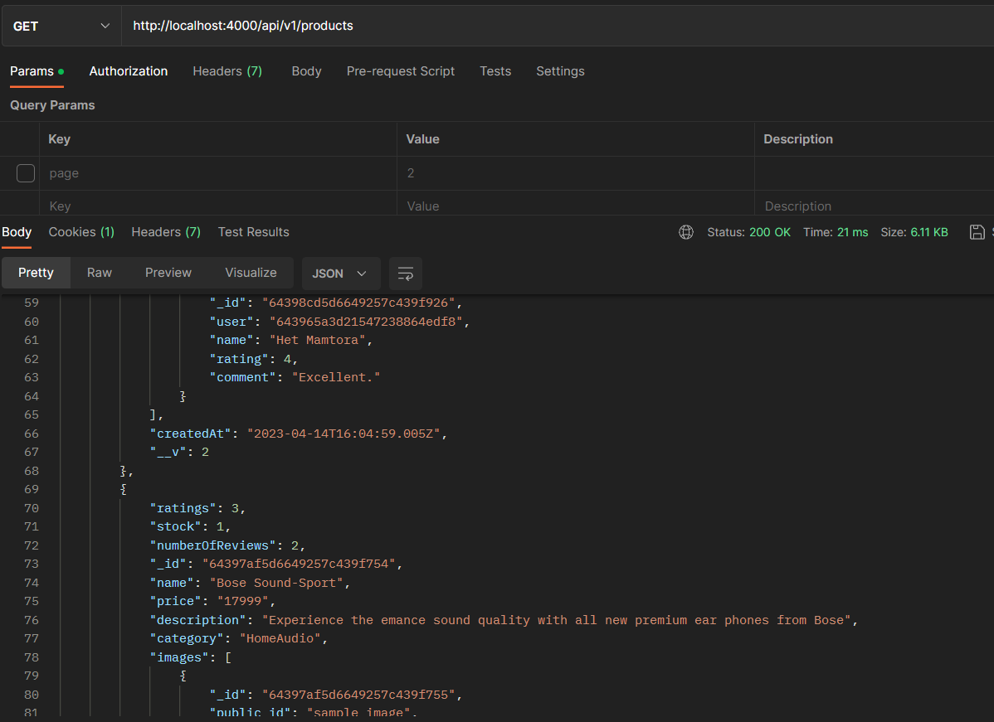

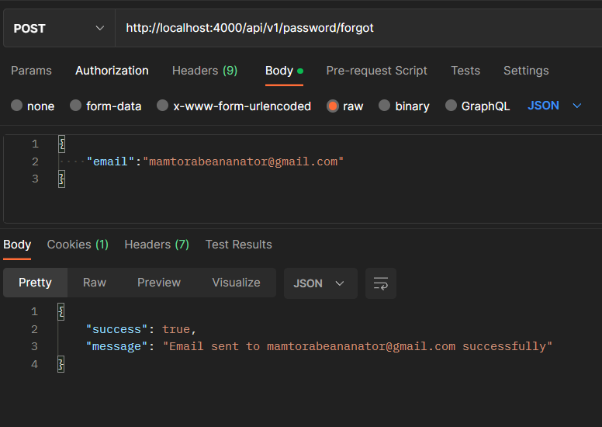

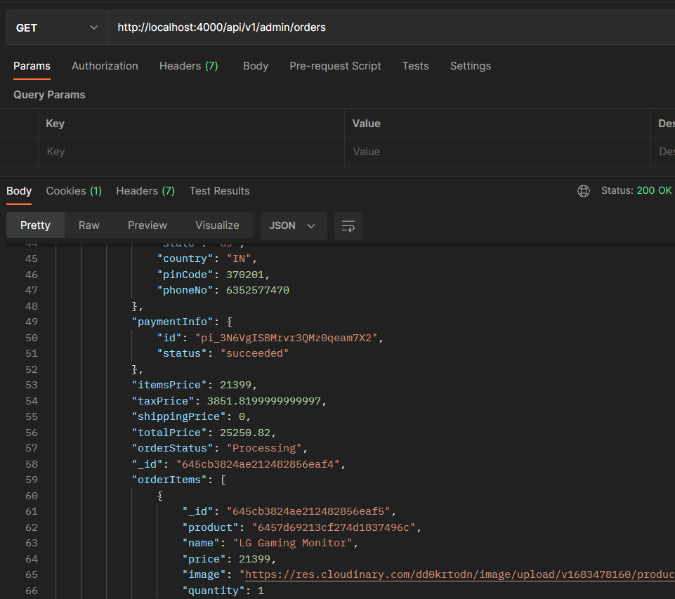

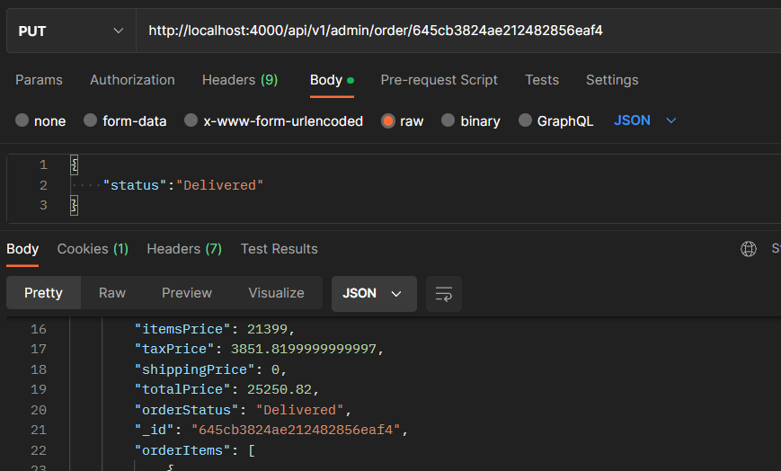

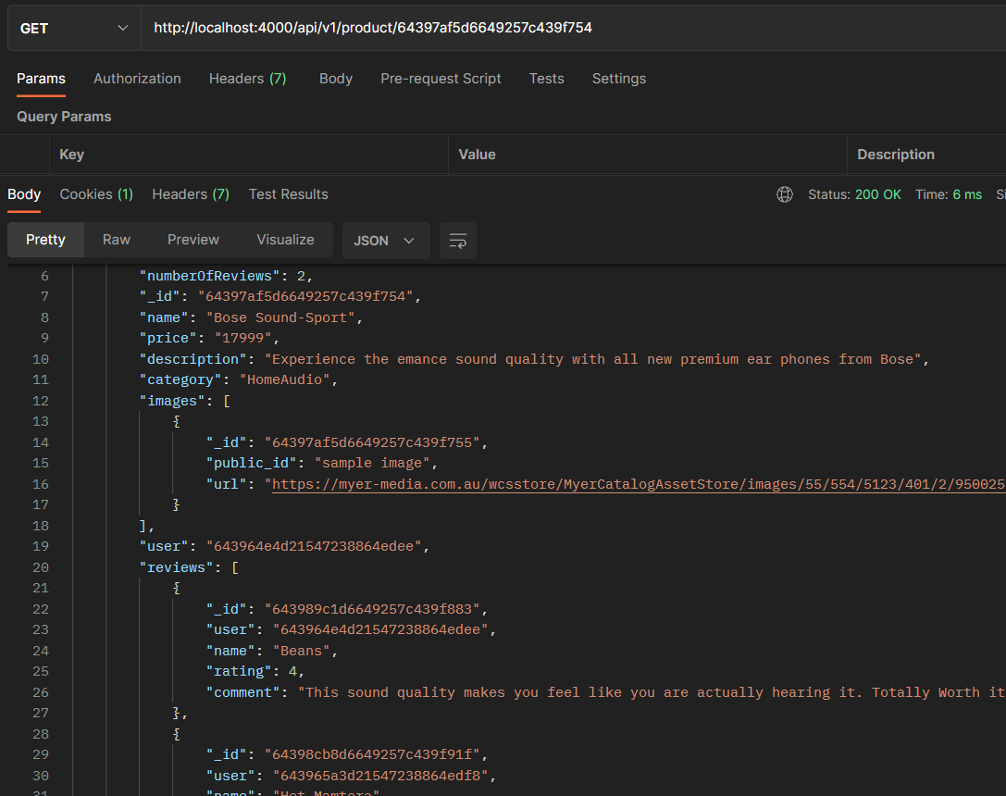

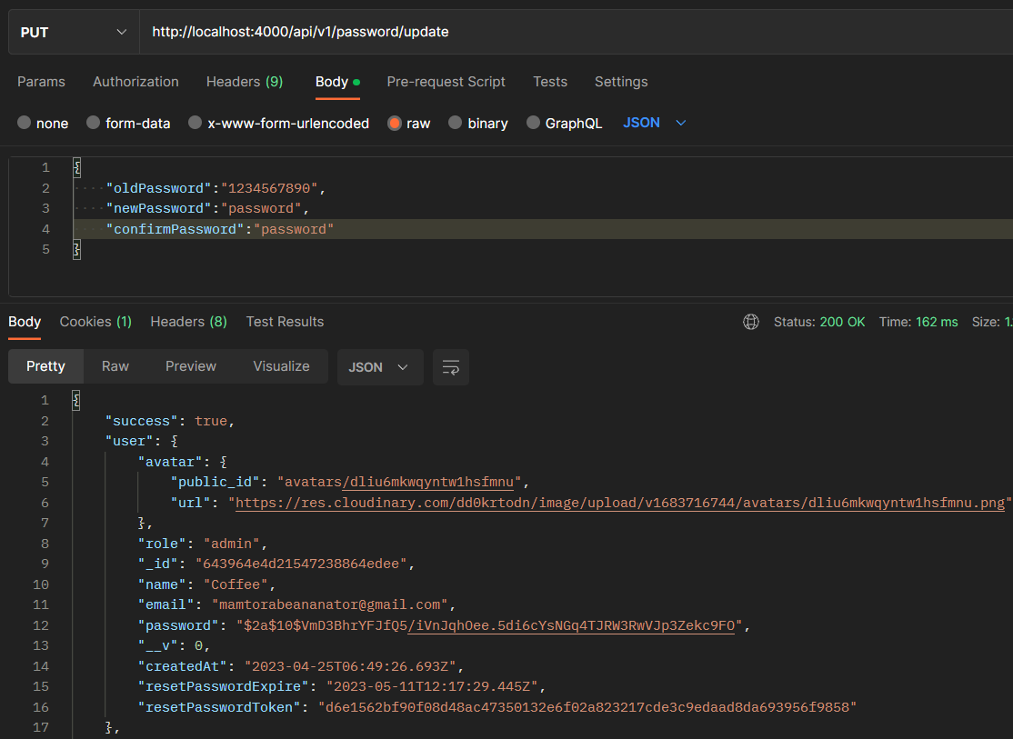

# **CHAPTER – 7: Future Work & Conclusion**

## **Future Work**

* For our future work I am aiming to improve the user interface of the E Commerce platform making it more interactive for our clients.
* Apart from that I am planning to expand the range of products available to them by adding more categories and subcategories.
* My goal is to provide personalized product recommendations to our customers based on their browsing history and previous purchases by implementing a recommendation system.
* Lastly, I am planning to develop a mobile app version for the e-commerce platform to provide better accessibility and convenience for our customers.

## **Conclusion**

* To conclude, although creating the Ecommerce Web app was challenging, it gave me a sense of fulfillment as I finished the project and learned a lot along the way.
* This journey made me gain experience in various areas such as front-end and back-end development, API integrations, database management etc.
* These skills and the challenges that I faced while working on the project will help me in my career journey.
* All in all, it was a fantastic opportunity for me to apply my technical skills and knowledge to a practical issue and create a product that can positively impact and benefit users.

# **APPENDIX**

| **TOOLS USED** | * VSCode * Postman * Mongoose * MongoDB Compass * Cloudinary * Stripe |
| --- | --- |
| **LANGUAGES**  **&**  **FRAMEWORKS** | * JavaScript * Node * Express * React * Redux ToolKit |

# **BIBLIOGRAPHY**

| 1. | <https://www.mongodb.com/docs/manual/> |
| --- | --- |
| 2. | <https://nodejs.org/docs/latest-v18.x/api/> |
| 3. | <https://legacy.reactjs.org/docs/rendering-elements.html> |
| 4. | <https://expressjs.com/en/guide/routing.html> |
| 5. | <https://learning.postman.com/docs/publishing-your-api/documenting-your-api/> |
| 6. | <https://redux-toolkit.js.org/introduction/getting-started> |
| 7. | <https://stripe.com/docs/payments?payments=online> |
| 8. | <https://cloudinary.com/documentation/cloudinary_guides> |

# **TURNITIN REPORT**

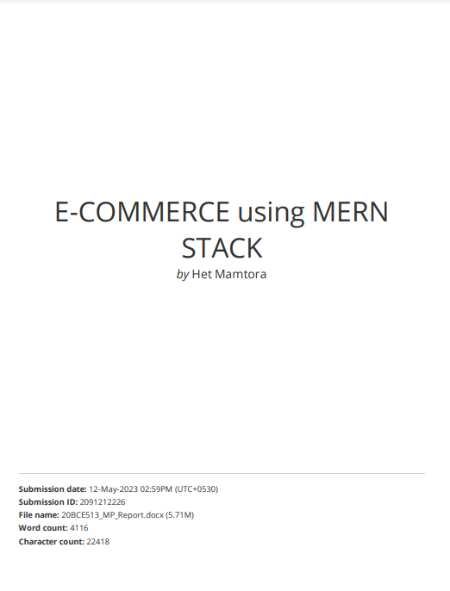

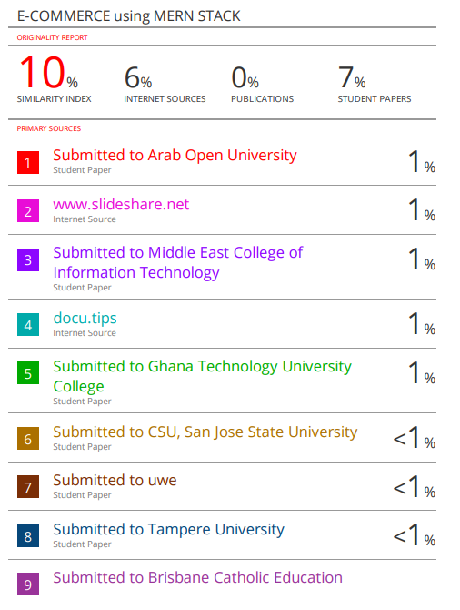

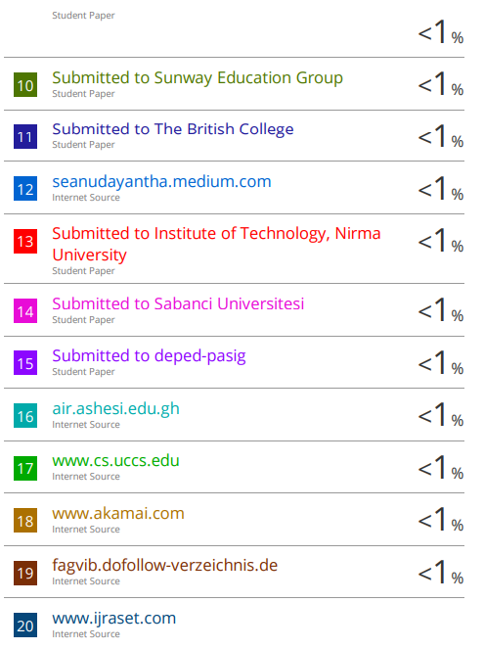

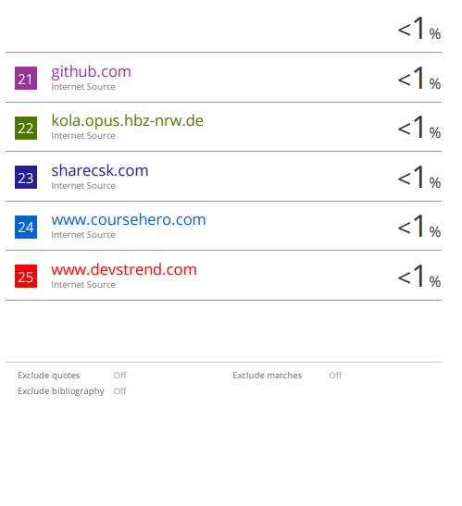

**THANK YOU**

**HET MAMTORA – 20BCE513**